MASON DIXON Blue and Gray
September 2016

~Member ~ National Corvette Restorers Society (NCRS)

~ NCRS TOP FLIGHT CHAPTER OF THE YEAR ~ Former Winners for Fourteen Consecutive Years

~ NCRS & Mason Dixon Activities ~ Judging Events – Rallyes – Drags – Cruisin’ Nights – Day Trips Banquets – Weekend Outings Annual Atlantic City Bus Tour
~ Charities ~ Support numerous Charities throughout the Great State of Maryland

Contents
Acting Chairman’s Report
Jim Buckley

Vice Chairman’s Report
Jim Buckley

Treasurer’s Report
Len Maiolatesi

Recording Secretary’s Report
Eileen Lesser

Membership Chairman’s Report
Len Maiolatesi

Judging Chairman’s Report
Rick Aleshire

Social Activities Chairman’s Report
Steve Lesser

Historian’s Report
Jerry Blumenthal

Website Coordinator’s Report
Tim Davis / Gus Tsamouras

Replacing 1999 Muffler
by James Buckley

Corvette History
Spotlight on 1992

Komedy Korner

Acting Chairman’s Report
Jim Buckley

Dear Fellow Chapter Members,
Yepper, there is a NEW sheriff in town for the next few months, until the real head cheese master Gus Tsamouras takes over. With that thought in mind - lets' rock-n-roll as they used to say!
Summer is almost over according to the calendar. Sure couldn't tell it by the many hot and humid days we have had lately. We also had many hot and wonderful venues of Corvette activities.
We had a great turnout at the Mt. Washington Pediatric Children's Hospital check presentation and the pool party afterwards. We want to thank the Lessers' for their hospitality in hosting the presentation and allowing us to do what Mason Dixon does so well - eat!
The NCRS National Convention in Warwick, RI was very well attended, as approximately 25% of our chapter members were there having cars judged; supporting members having their cars judged; receiving judging awards; and judging cars. We need to extend a hearty congratulations to our FIVE members who Top-Flighted!!
We had an enjoyable scenic trip from the Lessers' to the Elk Run winery that everyone enjoyed. The theme was Cars & Tunes, and we were treated to a duo that sang some old ballads from the likes of Johnny Rivers and Simon & Garfunkel.
Our picnic was a warm but enjoyable success. It was great to see all the Mason Dixon member Corvettes, plus Rick Aleshire's 1967 Camaro. So sorry that Ron Schoelkopf broke down just 1/2 a mile away and was unable to share his 1953 Packard with us.
Writing this short note before, but you will read after Corvettes at Carlisle. Always crowded but interesting and fun - and, supposed to be hot and humid - what else is new!!!
Come on out in your Corvette and try to attend as many of our activities as possible. You will enjoy yourselves and make every event better due to your being there.
Sincerely,
Jim Buckley, Acting Chapter Chairman
Mason Dixon Chapter, NCRS

Vice Chairman’s Report
Jim Buckley

Dear Fellow Chapter Members, Well, it has been another long hot summer, but a lot of activities with our Chapter have been great ones. The National was very successful with a high number of members from Mason Dixon attending. Steve Lesser has put together outstanding events for us to drive our Corvettes. Another Chapter Of the Year award was earned by our members. Thank you for all your help earning this award. Please come out and join us, as it is too early to park our Vettes away for their Winter "sleep". Also would like to thank those folks who attended the Mount Washington check presentation. Keep Cool, Vice Chairman, Jim

Treasurer's Report
Len Maiolatesi

As of 08/20/16, our checking account balance is $11,376.70. Thanks, Len
Recording Secretary’s Report
Eileen Lesser

Minutes of the Board of Directors Meeting
@ Jerry Blumenthal’s office
Lutherville, Maryland
August 10, 2016
Attendance:
Jim Buckley Rick Aleshire Jerry Blumenthal Tim Davis (abs)
Eileen Lesser Steve Lesser Gus Tsamouras Len Maiolatesi (abs)

Chairman’s Report:
After a light dinner, Jim Buckley began the meeting at 7:00 p.m. by thanking everyone who attended the recent National NCRS judging meet in Rhode Island. Mason-Dixon was well-represented with the following people in attendance:

Rick Aleshire, Tony Avedisian, Rich Ballard, Paul Bowes, Jack Brown, James Buckley, Dan DeVito, Tom Doi, Stan Falenski, Chuck and Pat Gongloff, Helena and Bob Jones, John Kane, Mike Levitas, Lea and Mike McCagh, Cay and Dennis Moore, Tony Soltyka, John St Peter, Alan Struck, Gus Tsamouras, John Yglesias, Gerry Yursis.

Vice-Chairman’s Report:
Jim Buckley announced that Mason-Dixon also received its 2015 decal for Chapter of the Year to add to our banner.

At the NCRS National Convention, we had FIVE members whose cars were judged and all FIVE received TOP FLIGHT! Mike Levitas (1965); Tony Avedisian (1966); Dan Devito (1966); Gerry Yursis (1968); Gus Tsamouras (1970).

Congratulations to Bob and Helena Jones as they received their 5th star for their Bowtie Award. We also need to congratulate Jack Brown for receiving his 5th star on his 1990 Crossed Flags award. Finally, we also want to congratulate John Kane and Jim Buckley on receiving their 200 level master judge awards; and Chuck Gongloff and Alan Struck on receiving their 300 level master judge awards.

Treasurer’s Report:
In Len Maiolatesi’s absence, Eileen gave an update on the Chapter Treasury which has $12,290.54 in it.

Membership Report:
In Len Maiolatesi’s absence, Eileen gave an update on the number of members in the Chapter (98).

Webmaster’s Report:
Gus discussed the updated Website Calendar. He will be deleting the June and July events as well as adding the photographs from the recent Mt. Washington Pediatric Hospital event.

Judging Chairman’s Report:
Rick discussed the recent judging at Tony’s Corvette Shop. He thanked all the Mason Dixon members who showed today to help judge the THREE Mason Dixon member cars. All THREE cars received Top Flight! So, when you see Tony Avedisian (1966) Chris Krieger (1972) and Dan Materazzi (1967), please congratulate each and everyone of them on their achievement!

Secretary’s Report:
Eileen Lesser discussed the recent donation of $1,650 at Mt. Washington Pediatric Hospital and the lunch and swim party afterwards. The MWPH administrator was also present at the after-party.

Social Activities Chairman’s Report:
Steve Lesser discussed the upcoming events: This Saturday, August 13, we will form a caravan to the “Classic Cars and Classic Tunes” at the Elk Run Winery in Mt. Airy, Maryland. The following Saturday, August 20, is our Paid-Up Membership luncheon at Sunshine Grill in Fork, MD. Steve told everyone that a flyer has been sent out about the upcoming “Corvettes at Carlisle” event in Carlisle, PA at the end of August. He has also confirmed our November Chapter dinner meeting at Liberatore’s Ristorante in Timonium, MD. At that event, we will also mention the “Cars at Christmas” event sponsored by AACA in Hershey, PA.

Historian’s Report:
Jerry discussed the new photos from the Mount Washington event which were sent to Gus and Tim to be posted on the Chapter website.

Old Business:
In Tim’s absence, Gus provided an update on the Chapter apparel program. Gus has sold an additional 13 shirts and Rick has sold 7 more items. Tim will bring the shirts and hats to each event so that our members may purchase the apparel.

Good and Welfare:
- Our continued get well wishes to Chuck and Pat Gongloff’s daughter, Mitzi;
- Congratulations to Angie and Vern Benson on the birth of their grandson, Jackson Anthony Benson
- Congratulations to Chuck and Pat Gongloff on their 47th anniversary;
- Congratulations to Charlotte and Jim Buckley on their 50th anniversary;
- Continued get well wishes to Gus Tsamouras.

The next Board meeting will take place on Wednesday, October 19, 2016 at 7:00 p.m. at Jerry Blumenthal’s office. All members are welcome to attend Board meetings, but please contact Eileen Lesser or one of the Board members to let us know you are coming so we order enough dinner.

Respectfully submitted,
Eileen Lesser
Recording Secretary
Web site: www.NCRS.org/masondixon

If you want to send a note through Yahoo, just e-mail the note to: mdncrs@yahoogroups.com
To start sending messages to members of this group, simply send e-mail to MDNCRS@yahoogroups.com If you do not wish to belong to MDNCRS, you may unsubscribe by sending an e-mail to MDNCRS-unsubscribe@yahoogroups.com If you are a member of other Yahoo e-mail lists, you may see and modify all of your group settings at: http://groups.yahoo.com/mygroups

Membership Chairman's Report
Len Maiolatesi

As of 08/20/16, we have 100 members. Please remember to pay your NCRS dues before your membership expires. You must be a current member of NCRS to remain a member of Mason Dixon. I will be emailing Mason Dixon membership dues forms the end of October. Thanks Len
Judging Chairman’s Report
Rick Aleshire

An excellent Judging school was presented by Tony Avedisian about Big Block cars. He had examples of the different parts that are unique with that option both original and reproductions to show the difference.

As was mentioned by several other BoD members, we had a very successful June judging meet at Tony's Corvette Shop. Three Chapter members attained Top Flight with each of their respective cars.

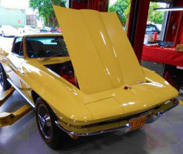
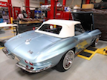
A 1966 Sunfire yellow 300 HP big tank, owned by Tony Avedisian scored a 99% Top Flight. The original owner of this beautiful, very rare, Big Tank car was a traveling Salesman that used the car for business and wanted the extra range.

Tony Avedisian - 1966 Dan Materazzi - 1967

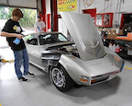

Chris Krieger - 1972

An Elkhart Blue 1967 350 HP convertible, wned by Dan Materazzi, scored a 97.4% Top Flight.

And, a Pewter Silver 1972 Coupe 250 HP w/T tops, owned by Chris Krieger that scored a 95.5 Top Flight. This is a very original car that’s a good Bowtie candidate.

In further judging new, Mason-Dixon was well-represented at the NCRS National Convention with the following people in attendance:

Rick Aleshire, Tony Avedisian, Rich Ballard, Paul Bowes, Jack Brown, James Buckley, Dan DeVito, Tom Doi, Stan Falenski, Chuck and Pat Gongloff, Helena and Bob Jones, John Kane, Mike Levitas, Lea and Mike McCagh, Cay and Dennis Moore, Tony Soltyka, John St Peter, Alan Struck, Gus Tsamouras, John Yglesias, Gerry Yursis.

Additionally, at the NCRS Convention, we had FIVE members whose cars were judged and all FIVE received TOP FLIGHT! Mike Levitas (1965); Tony Avedisian (1966); Dan Devito (1966); Gerry Yursis (1968); Gus Tsamouras (1970).

And, finally we offer congratulations to Bob and Helena Jones as they received their 5th star for their Bowtie Award on their 1978 Pace car. We also need to congratulate Jack Brown for receiving his 5th star on his 1990 Crossed Flags award. Finally, we also want to congratulate John Kane and Jim Buckley on receiving their 200-level master judge awards; and Chuck Gongloff and Alan Struck on receiving their 300-level master judge awards.

Social Activities Report
- Steve Lesser

As summer winds to a close, the best time to drive your Corvette is in the Fall. It’s not too hot and not too cold, and that small block or the big block loves the cool temperatures blowing through it. So let’s take the Corvettes out to the many events still left on the calendar.
Get set for a great time at the hayride and the brewery tour in Ijamsville, MD. You will be able to exercise your Corvette as well as your legs. Hope to see you at one of the cruising spots – Hunt Valley every Saturday morning or Marley Station every Saturday evening. It’s always great to sit around and talk with other Corvette members.
Mark your calendar now for the Fall Dinner Meeting on Saturday, November 12 at Liberatore’s Ristorante in Timonium, MD. Great Italian food with white tablecloth service.
Events Remaining for 2016:
Every Saturday – Hunt Valley Horsepower “Coffee and Cars” – every Saturday morning from 8:00-10:00 a.m. at Hunt Valley Mall before the mall opens;
October 22 – Hayride and corn maze in Ijamsville and tour of Flying Dog Brewery in Frederick; details to follow;
November 2 – Board Meeting at 7:00 p.m.;
November 12 – Fall Dinner Meeting (Liberatore’s Ristorante);
December – Happy Holidays!
Historian’s Report
Jerry Blumenthal

Folks, we really do need everyone’s help here! If you have any pictures, stories, etc. to share with us all, please let Jerry or any of the BOD know.

Website Coordinator’s Report
Tim Davis / Gus Tsamouras

The Newsletter is published in a single PDF file. It seems that many of our club members now have high-speed or broadband internet access, so we're hoping that the download issues of the past, might well be, well, past us! - Let us know if you can’ t read this.

Replacing 1999 Muffler
by James Buckley (23431)

To get started with the removal of the old driver-side muffler system, I used a penetrating spray
lubricant that I applied liberally to all the exhaust fasteners and allowed a significant period of time for the chemical to lubricate the threads before I attempted to disassemble everything.

With an 18 mm socket and a 15 mm wrench, I removed the brackets that secure the sway bar, one per side. The purpose is not to remove the sway bar, but to rotate it out of the way of the exhaust pipes which go up and over the rear axle.

I then disconnected the two bolts on the driver's side that held the muffler section to the H-pipe.
Ever wondered why they call an H-pipe an H-pipe? It resembles an H in shape. Notice the "cats" are forward (far right), near the back of the engine.

Since my 1999 Corvette is equipped with an automatic transmission, it has a gas tank heat shield (next to the transmission pan) that I needed to be loosened for clearance so I could remove the driver side exhaust pipe that goes over the rear axle. All I needed to do was pull the heat shield out of the way, as I did not need to entirely remove it.

Then I used a 13 mm socket on a long extension, to unbolt the rear muffler mount, on the driver's side. I made sure to be really cat-like to catch the muffler assembly when the muffler mount bolts were removed.

The following picture on the left shows why it sounded like I had straight pipes on the car! The pipe was on the driver's side, while the passenger side did not appear to have any signs of the deterioration shown on the driver's side. The second picture in the background shows the correct date-coded muffler I found at a salvage yare. In the foreground is the old muffler that I had removed.

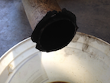
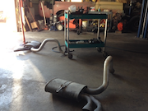

Prod
T

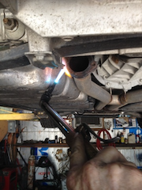
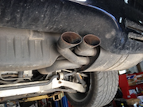

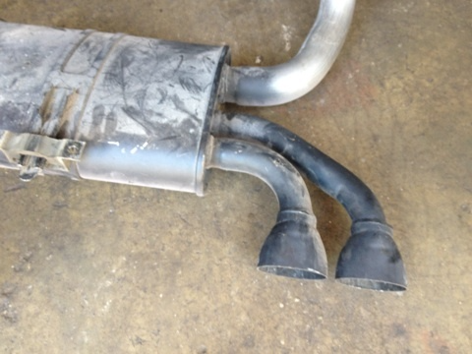
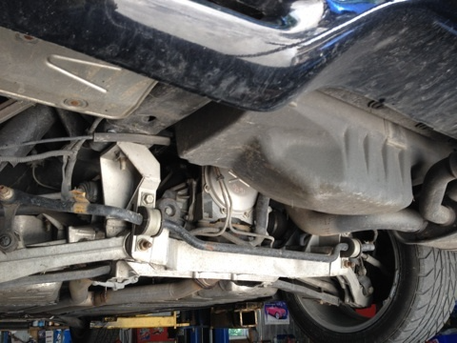

The above picture on the left shows me with my handy torch heating the mounting clamp up so I can remove the broken off exhaust pipe from the old muffler. The picture on the right shows the still very functional passenger side muffler. The bottom left picture shows the old removed muffler, while the right picture shows the empty area where I removed the muffler.

I reversed the above steps to mount the correct GM-part number and dated muffler back into the car. The car sounds just like a regular running Corvette, and my wife is a happy camper!

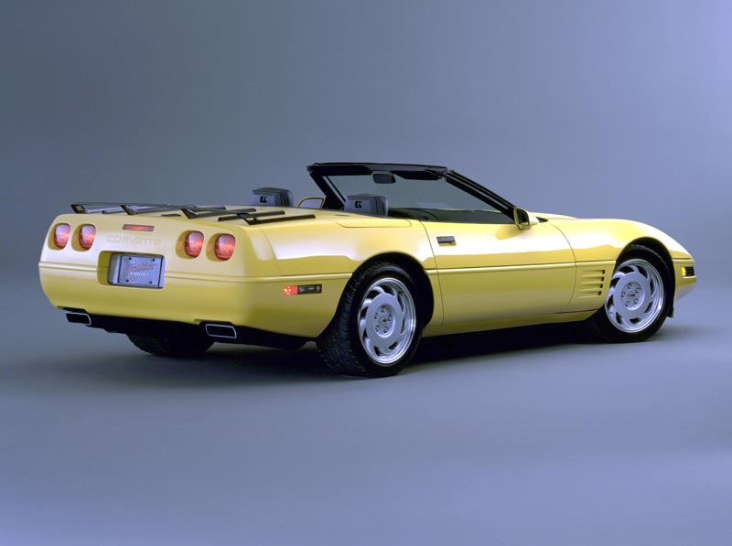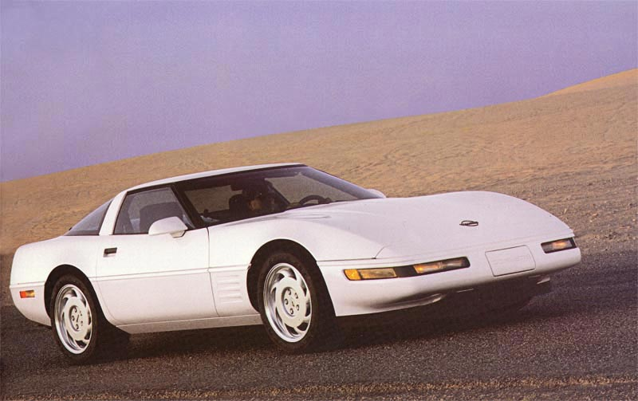
Official 1992 GM Photo
1992 was a very good year for the Corvette.
Starting in the mid 1970s, emissions regulations became a significant part of the performance automotive scene. Power output dropped dramatically; the 1975 Corvette was rated at only 165 hp. Car enthusiasts were concerned. If the present was bad, what would the future, which promised more stringent regulations, be like? It did not look good.
They need not have worried. What happened was a long, slow and sometimes painful return to speedier times. Corvette engines steadily gained about five or fifteen horsepower almost every year. By 1991 the L98 base Corvette engine was rated at 250 hp.
It all changed drastically with the introduction of the LT1, a new 300-hp 5.7 liter small block V8 motor in the 1992 Corvette.
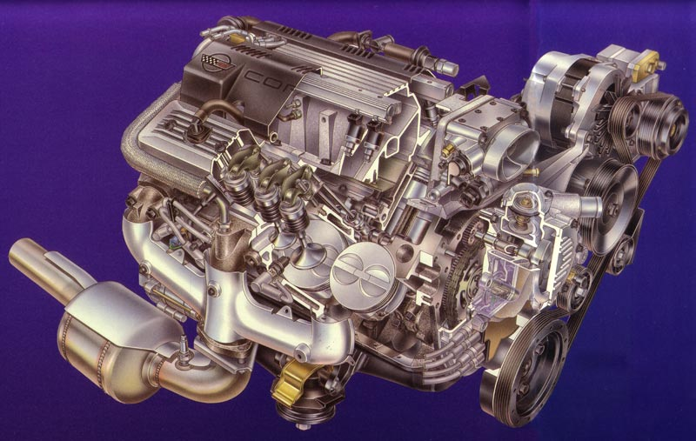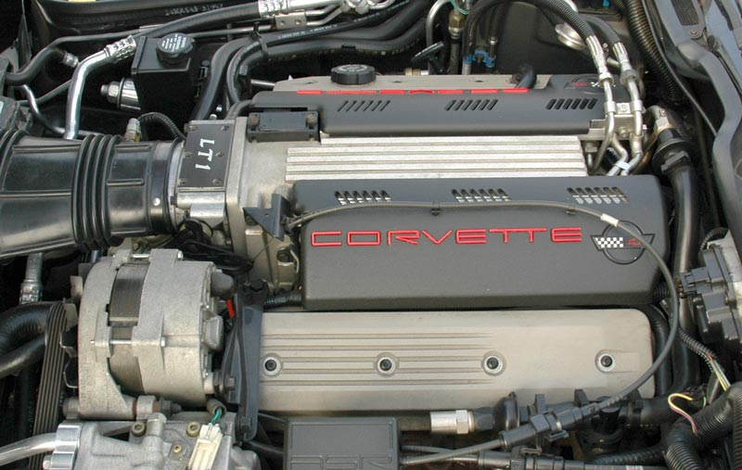

The LT1 was named after the highly regarded solid lifter small block LT-1 (note the hyphen) motor first used in the 1970 Corvette. The horsepower increased by 20% to 300 hp. This was accomplished by using computer controlled ignition timing, a low restriction exhaust system, a more aggressive camshaft profile and free-flow cylinder heads. Max. RPM was 5700, a whopping 700 RPM more than its L98 predecessor.
Probably the most interesting change in the LT1 was the revised cooling system strategy. Most engines route the coolant from the water pump to the block and through the head(s). In the LT1, coolant took the opposite path, starting in the cylinder heads and then cooling the engine block. Cooling off the heads first enabled the LT1 to reach new horsepower levels.
Also worth noting: All LT1 engines left the factory with Mobil 1, the recommended lubricant. The synthetic 5W-30 engine oil eliminated the need for a separate oil cooler.
More good news for 1992: The Corvette ASR (Acceleration Slip Regulation) created by Bosch was introduced. Standard equipment on all Corvettes, it worked by retarding the engine spark, closing the throttle and brake intervention. The throttle cable relax feature was interesting. It communicated to the driver that the system was "taking over" by giving him/her a gentle push back on the gas pedal. It was designed with the performance oriented driver in mind and could be switched off.
There was a dark side to all the technological progress. The new "Opti-spark" distributor had problems and were recalled early in the production run. According to some sources, given enough time, they would all fail if not replaced.
Something special also happened in 1992 —a white convertible with red interior, matching the first Corvette—rolls out of the Bowling Green facility on July 2, 1992: The One Millionth Corvette was built!
Production Options and Build Statistics

VEHICLE NUMBERS (VIN Numbers): 1G1YY23P6N5100001 - 1G1YY23P6N5119977
1G1YZ23J6N5800001 - 1G1YZ23J6N5800502 (ZR-1}

NOTE: For convertibles, sixth digit is a three.
Note: For Callaway Twin-Turbo, Chevrolet engine coding was replaced as follows: First two digits for year, next three digits for Callaway sequence, last four digits to match the last four digits of the vehicle identification number.
VIN Suffix: ZAA: 350 CUBIC INCH, 375 HORSEPOWER, MANUAL TRANSMISSION
ZAC: 350 CUBIC INCH, 300 HORSEPOWER, AUTOMATIC TRANSMISSION
ZUB: 350 CUBIC INCH, 300 HORSEPOWER, MANUAL TRANSMISSION

Engine Block Number: 10153558: 350 CUBIC INCH, 375 HORSEPOWER (ZR1)
10125327: 350 CUBIC INCH, 300 HORSEPOWER

Head Number: 10128374: 350 CUBIC INCH, 300 HORSEPOWER
10174390: 350 CUBIC INCH, 375 HORSEPOWER (RIGHT HAND)
10174389: 350 CUBIC INCH, 375 HORSEPOWER (LEFT HAND)

Production Options
RPO | Description |  | Price |  | Production
24S | Removable Roof Panel, blue tint (coupe) | 6,424 (31.37%) |  | $650.00
64S | Removable Roof Panel, bronze tint (coupe) | 3,005 (14.67%) |  | $650.00
AC1 | Power Passenger Seat | 16,179 (79.00%) |  | $305.00
AC3 | Power Driver Seat | 19,378 (94.62%) |  | $305.00
AQ9 | Sports Seats, leather | 7,973 (38.93%) |  | $1,100.00
AQ9 | Sports Seats, white leather | 709 (3.46%) |  | $1,180.00
AR9 | Base Seats, leather | 10,565 (51.59%) |  | $475.00
AR9 | Base Seats, white leather | 752 (3.67%) |  | $555.00
C2L | Dual Removable Roof Panels (coupe) | 3,739 (18.26%) |  | $950.00
C68 | Electronic Air Conditioning Control | 18,460 (90.14%) |  | $205.00
CC2 | Auxiliary Hardtop (convertible) | 915 (4.47%) |  | $1,995.00
FX3 | Selective Ride and Handling, electronic | 5,840 (28.52%) |  | $1,695.00
G92 | Performance Axle Ratio | 2,283 (11.15%) |  | $50.00
MN6 | 6-Speed Manual Transmission | 5,487 (26.79%) |  | n/a
NN5 | California Emission Requirements | 3,092 (15.10%) |  | $100.00
U1F | Stereo System with CD, Delco-Bose | 15,199 (74.22%) |  | $1,219.00
UJ6 | Low Tire Pressure Warning Indicator | 3,416 (16.68%) |  | $325.00
UU8 | Stereo System, Delco-Bose | 3,241 (15.83%) |  | $823.00
V56 | Luggage Rack (for convertible) | 845 (4.13%) |  | $140.00
Z07 | Adjustable Suspension Package (coupe) | 738 (3.60%) |  | $2,045.00
ZR1 | Special Performance Package (coupe) | 502 (2.45%) |  | $31,683.00

Total Production: 20,479
Coupe: 14,604 (71.31%)
Convertible: 5,875 (28.69%)
Notes: Base Corvette Coupe with 350 cu. in. 300 hp engine and four speed automatic transmission: $33,635.00.
Base Corvette Convertible with 350 cu. in. 300 hp engine and four speed automatic transmission: $40,145.00.

Colors
Interior options for exterior colors are suggested by Chevrolet. Other combinations could be ordered.

Code | Exterior | Quantity | Interior | Soft Top
10 | White | 4,101 (20.03%) | Black / Light Beige / Light Gray / Red / White | Blue / Beige / Black / White
35 | Yellow | 678 (3.31%) | Black / Light Beige / Light Green / White | Beige / Black / White
41 | Black | 3,209 (15.67%) | Black / Light Beige / Light Gray / Red / White | Beige / Black / White
43 | Bright Aqua Metallic | 1,953 (9.54%) | Black / Light Beige / Light Green / White | Beige / Black / White
45 | Polo Green II Metallic | 1,995 (9.74%) | Black / Light Beige / White | Beige / Black / White
73 | Black Rose Metallic | 1,886 (9.21%) | Black / Light Beige / Light Green / White | Beige / Black / White
75 | Dark Red Metallic | 1,148 (5.61%) | Black / Light Beige / Light Green / White | Beige / Black / White
80 | Quasar Blue Metallic | 1,043 (5.09%) | Black / Light Beige / Light Green / White | Beige / Black / White
81 | Bright Red | 4,466 (21.81%) | Black / Light Beige / Light Green / Red / White | Beige / Black / White

Komedy Korner
Hilarious Church Bulletin Flubs!!!!
Join the Choir - "The senior choir invites any member of the congregation who enjoys sinning to join the choir."
"Next Thursday there will be tryouts for the choir. They need all the help they can get."
Bell Choir - "At the evening service tonight, the sermon topic will be “What is Hell?” Come early and listen to our bell choir practice."
Bean Supper - "A bean supper will be held Saturday evening in the church basement. Music will follow."
Potluck Supper - "Thursday night — Potluck Supper. Prayer and medication to follow."
Electric Girdles - "The pastor would appreciate it if the ladies of the congregation would lend him their electric girdles for the pancake breakfast next Sunday morning."
Prepare to Sin - "This evening at 7 pm there will be a hymn singing in the park across from the Church. Bring a blanket and come prepared to sin."
End of a Friendship - "Irving Benson and Jessie Carter were married on October 24 in the church. So ends a friendship that began in their school days."
Rummage Sale - "Ladies, don't forget the rummage sale. It's a chance to get rid of those things not worth keeping around the house. Don't forget your husbands."
Wonder What She Ate? - "Bertha Belch, a missionary from Africa, will be speaking tonight at Calvary Methodist. Come hear Bertha Belch all the way from Africa."
Respect Your Elders - "Eight new choir robes are currently needed, due to the addition of several new members and to the deterioration of some older ones."
Prayer & Fasting - "National PRAYER & FASTING Conference: The cost for attending the Fasting and Prayer conference includes meals."
Church Parking - "When parking on the north side of the church, please remember to park on an angel."
Gracious Hostility - "The church will host an evening of fine dining, superb entertainment, and gracious hostility."
Don't Know You Have Children? - " For those who have children and don't know it, there is a nursery downstairs."
Lay an Egg - "This being Easter Sunday, we will ask Mrs. Jones to come forward and lay an egg on the altar."
Tragedy - "The eighth-graders will be presenting Shakespeare's Hamlet in the Church basement Friday at 7 PM. The Congregation is invited to attend this tragedy."
Up Your Pledge - "The Associate Minister unveiled the church's new tithing campaign slogan last Sunday: "I upped My Pledge - Up Yours."
We Could Be Here a While - "The audience is asked to remain seated until the end of the recession."
Blessed Assurance - "The third verse of Blessed Assurance will be sung without musical accomplishment."
Kiss the Cook - "Men's Prayer Breakfast. No charge, but your damnation will be gratefully accepted."
Seems a Little Young - "Applications are now being accepted for 2 year-old nursery workers."
Remember the Sick - " Remember in prayer the many who are sick of our congregation."
Fix That Piano! - "The concert held in Fellowship Hall was a great success. Special thanks are due to the minister's daughter, who labored the whole evening at the piano, which as usual fell upon her."
He Loves What? - " Please welcome Pastor Don, a caring individual who loves hurting people."
One Big Baby - " Please join us as we show our support for Amy and Alan who are preparing for the girth of their first child."
Full On What? - "Today's Sermon: HOW MUCH CAN A MAN DRINK? With hymns from a full choir."
Don't Be Late! - "Ushers will eat latecomers."
Guns? - "Next Sunday is the family hayride and bonfire at the Fowlers. Bring your own hot dogs and guns. Friends are welcome! Everyone come for a fun time."
The Preacher and the Friendly Ghost
A new preacher wanted to rent a house in the country but the only one available was rumored to be haunted. That didn’t bother the preacher since he didn’t believe in such things. He went ahead and rented the place. Soon the ghost made its appearance. The preacher told his friends about the ghost, but they didn’t believe him. They told him the only way they would believe was if he took a picture of the ghost.
The preacher went home and called for the ghost. When it appeared, the preacher explained the situation and asked the ghost if it would mind having its picture taken. The ghost agreed. When the picture was developed, the ghost wasn’t visible.
Feeling disappointed, the preacher called again for the ghost. When it appeared, the preacher showed it the picture and wanted to know why the ghost wasn’t in it.
The ghost thought a minute and replied, “Well, I guess the spirit was willing, but the flash was weak.”
Funny Church Billboards
Don't Make Me Come Down There
Give God What's Right - Not What's Left!
Read the Bible - It Will Scare the Hell Out of You!
Dust on Your Bible Could Lead to Dirt in Your Life!
You Have One New Friend Request from Jesus - Please Check Confirm or Ignore!
Get off Facebook and Into My Book - God!
God does NOT Believe in Atheists - Therefore Atheists do Not Exist!
Free Coffee - Everlasting Life - Yes, Membership has it's Privileges!
Forbidden Fruits Create Many Jams!
Get RIGHT! or Get Left!
God is Like Tide Soap - He Gets the Stains Out Others Left Behind
Why Pay for GPS? Jesus Gives Direction for Life
Jesus - Your Get Out Of Hell Free Card!
I'm Also Making a List and Checking it Twice - God!
Life is a Puzzle - Look Here for the Missing Peace!
To Err is Human - To ARRRR is Pirate!
Sign Broke - Message Inside!
Son Screen Prevents Sin Burn!
Keep Using My Name in Vain - I'll Make Rush Hour Longer - God!
Will the Road You're On Get You to My Place? - God
"Try Jesus!" If You Don't Like Him, the Devil Will Take You Back!
Easter is More than Something to Dye For!
Honk if You Love Jesus! Text While Driving if You Want to Meet Him!
What is Missing from Ch ch - U R!
God Wants Spiritual Fruits not Religious Nuts!
There are Some Questions that can NoT Be Answered by Google!
If You Would Shut Up - You Would Hear God's Voice!
Need a Lifeguard? Ours Walks on Water!
Prayer - Wireless Access to God with NO Roaming Fee!
Sin Knocks a Hole in Your Bucket of Joy!
Be an Organ Donor - Give Your Heart to Jesus!
When Jesus was Born
Saints Dominic, Francis of Assisi, and Ignatius of Loyola are transported back in time and place to the birth of Our Lord. St. Dominic, seeing the Incarnation of the Word, is sent into ecstasy. St. Francis, seeing God become a helpless child, is overcome with humility. St. Ignatius of Loyola takes Mary and Joseph aside and asks, “Have you given any thought to his education?”
The Evangelizing Barber
There was a barber who paid close attention at his parish whenever the topic of evangelization was discussed. He thought he should be doing more to share his faith with his customers. The next morning the barber told the Lord in prayer, “Today I’m going to witness to the first customer who walks through my door.”
A man came in as he opened his shop and said, “I need a shave.”
The barber said, “Yes sir! Just have a seat and I’ll be right with you.” The barber went in the back and prayed a quick prayer saying, “Lord, the first customer just came in and I’m going to witness to him. Give me the wisdom to know just the right thing to say. Amen.”
Then the barber came out with his straight razor in one hand and a Bible in the other and told his customer, “I have a question for you: Are you ready to meet your Maker?”

Where did She Go!?
An elderly woman in her nineties had a visitor from her church come to see her at the nursing home. “How are you?” the visitor asked.
“Oh,” said the elderly woman, “I’m just worried sick!”
“You look like you’re in good health. They take good care of you here, don’t they?”
“Oh, yes, they take good care of me here.”
“Do you have any pain?” the visitor asked.
“No, I can’t say I do,” the elderly woman replied.
“Then what has you worried sick?” the visitor asked.
The elderly woman leaned in and explained, “All of my closest friends have already died and gone to heaven. I’m sure they are all wondering where I went!”
Biblical bumper stickers:
Jonah: Save the Whales
The Israelites: Honk If You Love Moses
Elijah: My Other Chariot Rolls
Goliath: Support the Ban on Slingshots
Lot: If You Can’t See Sodom, You’re Too Close
Methuselah: Be Kind to Senior Citizens

