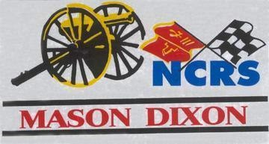

MASON DIXON Blue and Gray
December 2018

~Member ~ National Corvette Restorers Society (NCRS)

~ NCRS TOP FLIGHT CHAPTER OF THE YEAR ~ Former Winners for Fifteen Consecutive Years

~ NCRS & Mason Dixon Activities ~ Judging Events – Rallyes – Drags – Cruisin’Nights – Day Trips - Banquets – Weekend Outings -
Annual Atlantic City Bus Tour

~ Charities ~ Support numerous Charities throughout the Great State of Maryland

Contents

Chairman’s Report
Gus Tsamouras

Vice Chairman’s Report
Jim Buckley

Treasurer’s Report
Rd Ranier

Recording Secretary’s Report
Eileen Lesser

Membership Chairman’s Report
Glenn Gitschier

Judging Chairman’s Report
Rick Aleshire

Social Activities Chairman’s Report
Steve Lesser

Historian’s Report
Jerry Blumenthal

Website Coordinator’s Report
Jim Cella

Replacing Air Conditioning Compressor on 1998
James Buckley - NCRS #23431

Prepping 1970 Corvette for Primer / Paint
James Buckley - NCRS #55336

Corvette History
Spotlight on 2001

Komedy Korner
Chairman’s Report Gus Tsamouras

Hello Fellow Mason Dixon Chapter Members!

Well, here we are getting close to the end of the year and what a year it was for our Chapter!
I would have to say that this may be one of the best years we have had in a long time. Our social calendar was full of great events and well attended. We expanded our membership and also had many new members participate and help at many of our events.

Our judging year which was led by Rick Aleshire was once again a great success. We had multiple Top Flight cars from our own membership and many who participated at our events. I would like to give Ron Adams a very special Thank you for letting us use his dealership once again. It is much appreciated.

Our second annual garage crawl was also a great time. We got to go see goodies that our members have in their garages followed by a great lunch get together. This has been a great success and I look forward to next years' garage crawl.

Once again we did charity work for the Mount Washington Pediatric Hospital, and also helped with the Erin Levitas foundation as our 2nd charity for the year.

Our Ask the Experts event was at TPC Racing this year and was just fantastic! For those of you who don't know, the Levitas family owns and operates TPC. They were more than warm welcoming and showed us such great vehicles and taught us some great lessons and gave us great information about their racing program.

As usual, our dinners were well attended and Steve Lesser and his boss Eileen did a fantastic job gathering prizes and gifts.

On a sad note we lost two long time members Bob Jones and Norbert Bertling. Both were Corvette lovers and active members. On behalf of the Chapter I would like to give our condolences to their families.

And lastly I want to give a HUGE Thank You to the entire board and the many volunteers who help make this great Chapter what it is.

Sincerely,
Gus Tsamouras, Chapter Chairman
Mason Dixon Chapter, NCRS

Vice Chairman’s Report
Jim Buckley

Dear Fellow Chapter Members,

Well, this year has passed by so quickly, and we had a lot of Corvette events going on. The Winter time is upon us, but do not put your Corvette away too soon. We still have the occasional "nice" day to drive our Corvettes. Sitting dormant is probably the last thing you want to subject them to.
Also, the BoD has many more ideas for 2019 to drive our cars. Steve and Eileen, have once again performed an outstanding job of finding events for us to do, as well as putting the dinners together too.

So please come out in 2019 and join the "FUN".

Be there or be square........Vice Chairman, Jim

Treasurer's Report
Ed Ranier

The balance on the account, per the last bank statement for 12/3/18, was $15,023.54. The current, adjusted balance, as of 12/3/18, is $15,023.54, according to the checkbook. Thanks, Ed

Recording Secretary’s Report
Eileen Lesser
Minutes of the General Fall Dinner Meeting
Liberatore’s Ristorante
Timonium, Maryland
Saturday, November 10, 2018

Attendance: Approximately 55 members attended the General Fall Dinner Meeting.

Chairman’s Report: After a lovely dinner, Gus discussed the following items at the Fall Dinner Meeting:
- Changing the logo on our new Chapter apparel; we will take a vote at the dinner meeting to see if we would like to change the logo on the apparel; Gus showed the new logo and took a vote;
- Thanked the Hendersons and the Predigers for donating gifts as door prizes;
- He mentioned the donations the Chapter made to the Levitas Foundation and the Mt. Washington Pediatric Hospital;
- Gus introduced the newest members of Mason Dixon; (see below)
- Gus also announced that our member, Norbert Bertling, passed away November 9.

Vice-Chairman’s Report: Jim Buckley announced that our statistics are up-to-date and we have obtained another Chapter of the Year Award this year.

Treasurer’s Report: Ed gave an update on the Chapter Treasury which has $13,305.97 in it.

Membership Report: Glenn gave an update on the number of members in the Chapter (98 members).

Webmaster’s Report: In Jim Cella’s absence, Gus mentioned that “For Sale” items are limited to 30 days on the website. Apparel will also be on our website in the near future.

Judging Chairman’s Report: Rick needs technical articles for the next “Blue and Gray” Newsletter as well as cars to be judged. If you would like to have your Corvette judged, contact Rick Aleshire at mdninja1@hotmail.com.

Secretary’s Report: Eileen Lesser read the “Good and Welfare” to the dinner guests. (see below)

Social Activities Chairman’s Report: Steve Lesser wished everyone a happy and safe holiday season. Steve thanked Juliet Page for donating her hand-made jewelry to the dinner as door prizes, as well as JBA Chevrolet, BreakThru Beverage (formerly Reliable-Churchill), Fred and Dawn Prediger, Harold and Franzine Henderson for the Corvette apparel. Tonight’s festivities continued with Andy Anders playing his guitar and singing Corvette songs. After all the door prizes were distributed, Steve Lesser became an auctioneer and auctioned off additional gifts and apparel for the Treasury.

Historian’s Report: Jerry brought Mason-Dixon previous photographs to the dinner for all the members to view.

Good and Welfare:
- Congratulations to Dawn Prediger who recently retired from McCormick;
- Congratulations to Gus Tsamouras who brought home a National Top Flight Award for his 1970 Stingray;
- Congratulations to Nelson Smith who entered the NCCC judging in Concourse B with his ’65 and won his class and Best in Show at Corvettes at Carlisle;
- Congratulations to Donna Bertling, wife of Norbert Bertling, whose latest novel has come out entitled “Runaway Fire” about the Great Baltimore Fire of 1904’
- Congratulations to Fred Prediger who recently retired from his position after 40 years;
- Congratulations to Mike Levitas and his TPC racing team. They took 2nd place in the 2018 Gold Cup Championship, the 2018 Gold Cup charger, and a P3 finish at Motul Petit Le Mans;
- Congratulations to Rick Aleshire who worked on the Largest Corvette-Club Sponsored Event on the East Coast in Ocean City, MD - Free State Corvette Weekend in Ocean City is the largest Corvette Club-sponsored event on the east coast. Free State Corvette Club President, Craig Steinbock explains, "Corvette Weekend is a gathering of Corvette enthusiasts to come form all over the east coast and other countries. www.wrde.com;
- Our deepest condolences to Garnette and Chuck Walker on the loss of Garnette’s mother, Carrie Weber;
- Our deepest condolences to Donna Bertling on the loss of her husband, Norbert;
- Congratulations to Julie Sokoloff who won the Club Golf Championship at Radnor Valley.

The meeting ended at 10:20 p.m.

Respectfully submitted, Eileen Lesser
Recording Secretary

Web site: www.NCRS.org/masondixon
If you want to send a note through Yahoo, just e-mail the note to "mdncrs@yahoogroups.com". To start sending messages to members of this group, simply send e-mail to "MDNCRS@yahoogroups.com". If you do not wish to belong to MDNCRS, you may unsubscribe by sending an e-mail to "MDNCRS-unsubscribe@yahoogroups.com". If you are a member of other Yahoo e-mail lists, you may see and modify all of your group settings at http://groups.yahoo.com/mygroups

Membership Chairman's Report Glenn Gitschier

As of 12-12-18, we have 97 members in our Chapter. Our latest members to join are Dolores and Greg Connelly, Jeanne and Joe Kidd, and Ira S. Katz who all joined during the month of August 2018. Welcome!!

It is very IMPORTANT that you notify the National and our Chapter if you change your email address. The National NCRS sends out reminder emails several months before the expiration date, so PLEASE don't ignore these reminders. I have also been sending emails and calling members if I see your National NCRS membership is going to expire within one month. Contact me (410-688-7329) if you want to know when your National NCRS membership expires. You must be a current member of National NCRS to remain a member of Mason Dixon. PLEASE REMEMBER to send your 2019 DUES payment!!! Thanks, Glenn

Judging Chairman’s Report Rick Aleshire

On Sunday, September 30 at Greg Connelly's house in Essex, MD we practice judged a beautiful 1953 and 1957 owned by new member Greg Connelly. The following are pictures of the practice judging and are provided courtesy of Jim Buckley.
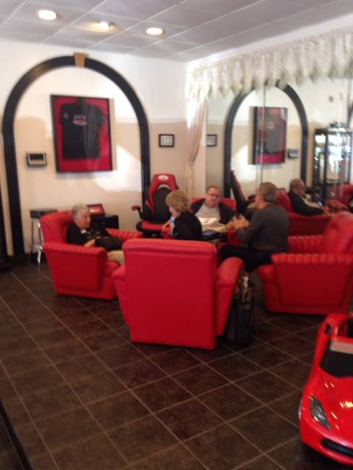
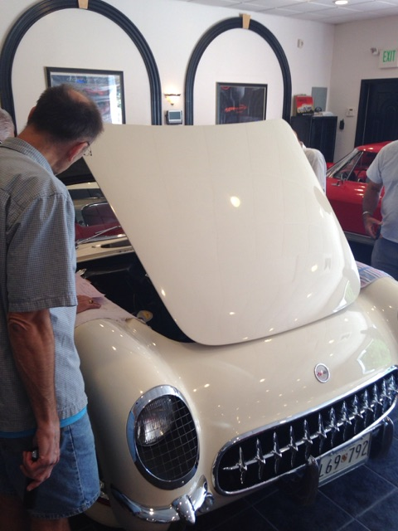
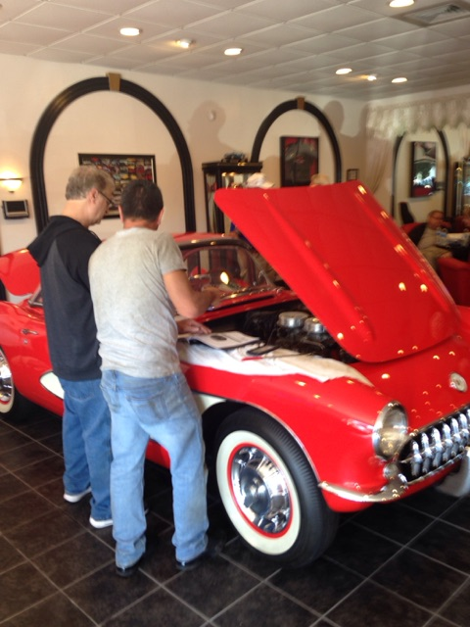

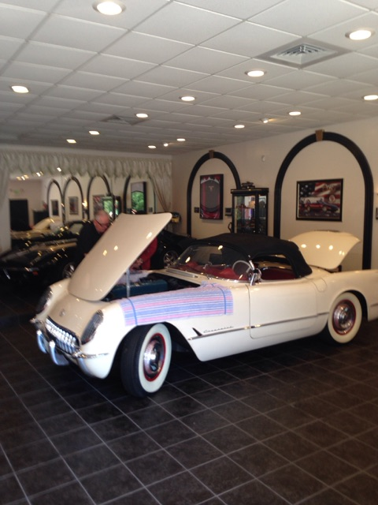
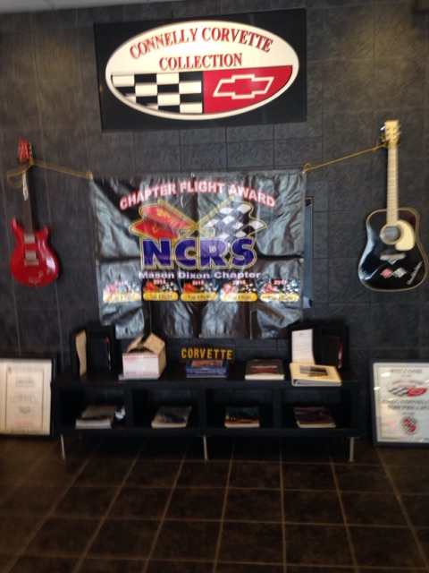
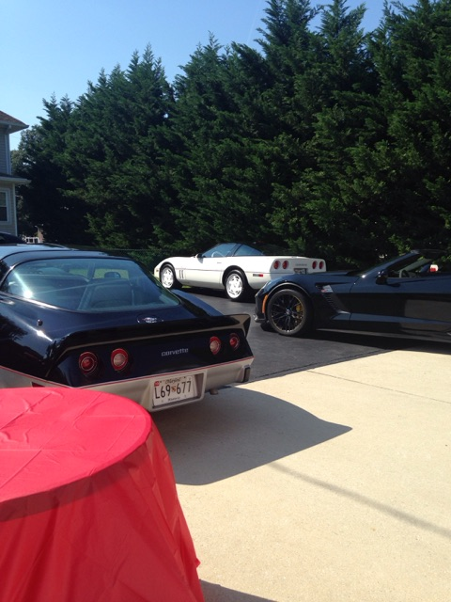

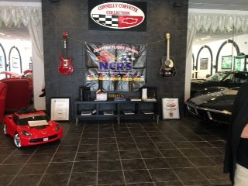
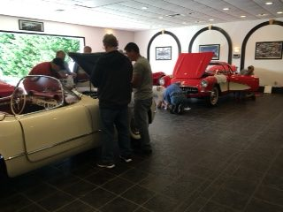

Mason Dixon @ Social Activities Report
Steve Lesser

2019 will be an exciting year for Mason Dixon. We will have lots of fun activities, caravans, judgings, luncheons and dinners, and different ways to use your Corvettes.

The official calendar of events will be discussed at the next Board meeting in January, and you will get a copy of the calendar listing all the activities that are planned.

If the roads are clear, and you feel like braving the cold, come out to Hunt Valley Mall for “Coffee and Cars” every Saturday morning from 8:00-10:00 a.m. Bundle up because it is usually chilly, but you will see some great automobiles. You can always go into many of the restaurants for a quick bite and to warm up.

Have a Merry Christmas, a Happy Chanukah, and a Happy New Year!

If you have an idea for a fun event, let me know – eileen3304steve@verizon.net.

Historian’s Report Jerry Blumenthal

Folks, we really do need everyone’s help here! If you have any pictures, stories, etc. to share with us all, please let Jerry or any of the BoD know.

Website Coordinator’s Report
Jim Cella

Folks, as the webmaster, I would like to get any comments, suggestions, etc. on the layout of the website. Again, this is your Chapter website and I will work to provide the information you need / want, but need to know. Thanks, Jim

Replacing Air Conditioning Compressor on 1998
James Buckley - #23431

First disconnect and remove the battery and the rubber surround as it will be in the way for the accumulator removal. Drain the coolant for the water pump removal. Purchase new gaskets, they are cheap at any local autoparts store. Remove the belts and hoses then I think 6 water pump bolts w/ a 10 mm socket?

Next, assuming your system is dry (all refrigerant has leaked out or escaped) if not it should be removed with a refrigerant recovery system that most diy people don't have.
Raise the passenger side of the car and remove the wheel, this is to access the two lower compressor bolts.

Remove the one bolt at the rear of the compressor attaching the lines to the compressor. I can't recall the size 13mm maybe? Then the four (two upper & two lower bolts) one of the uppers looks like a stud but it also comes out. Unfasten the wire connector at the clutch and yank it outa there.
Note: if your replacement compressor was shipped with out oil you should try not spilling any from your old compressor as you will need to drain and measure the amount to add to your replacement with new oil. The manual has a replacement amount for this ( I think 3 oz. not sure). I use PAG 46 oil available at most autoparts stores. I also use it to lube the o-rings although the book calls for refrig.525 oil.
The accumulator (receiver/drier) has two tube fittings which are hard to wrench (very close quarters) make certain you use a backup french on the fitting while loosening and tightening these! Remove the two srews holding the bracket to the fire wall (10mm maybe?) and again the drier should be drained of oil and measured for the new oil amount to be replaced. I found this difficult as the desicant bag inside tends to not allow it to drain out. There is a standard amount called out in the manual for replacement (not sure w/out my books 2oz. I think).
Finally, you should replace the orifice tube (expansion device). If you don't have one of these you will also want to replace it. It is located inside the liquid (small) line which is very near the area of the engine dipstick.
It looks like another line fitting. Use a backup wrench and lossen the nut then pull the line apart. The orifice tube is inside the line toward the fire wall. Reach in there with a pair of needle nose pliars and pull it out carefully (it is plastic) it should also come out with it's o-ring. Take note of the direction of the thing so that you install the new one correctly, some have a tiny direction arrow and it should face toward the drier or fire wall.
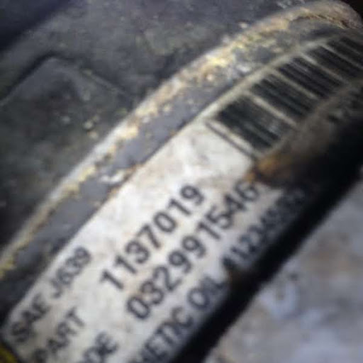
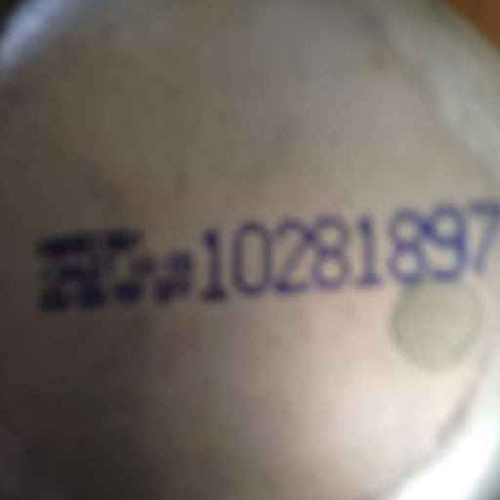
The following pictures are of the GM original old compressor and drier and then the new "replacement" compressor.

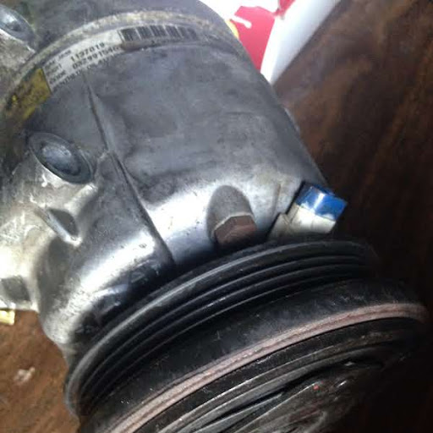
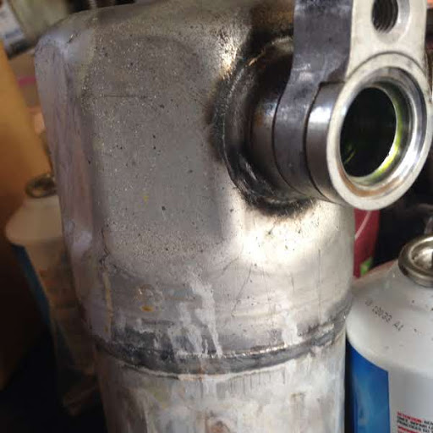

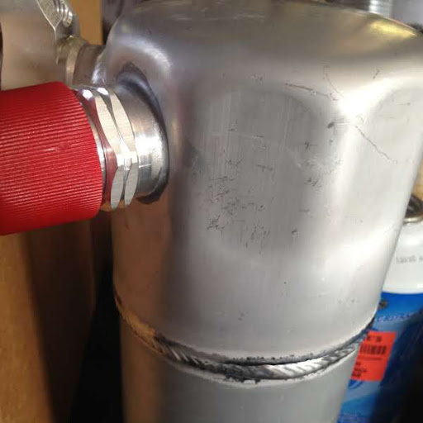
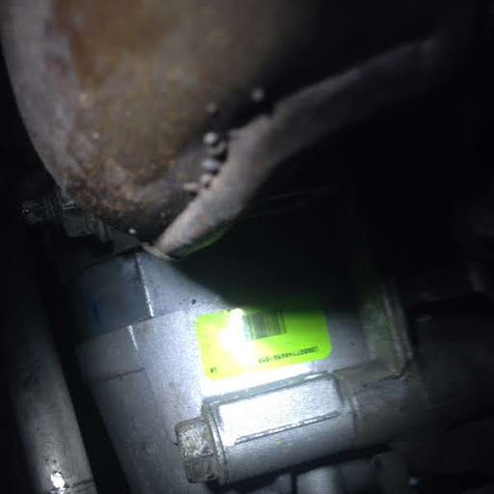

Prepping 1970 Corvette for Primer / Paint
James Buckley - NCRS #55336

The following article / pictures provide some insight into the steps needed to be taken to prep the car for primer and then the painting process.

Sand the surface of the fiberglass car with 120 grit sand paper on a long sanding block. This roughens the surface and prepares the car for primer. This step also allows you to see any dings, dents or warped areas of the fiberglass that need to be repaired.
Wipe the surface of the car with wax and grease remover and a lint free cloth. Spray three coats of urethane on the car. Use light, even coats of primer so it doesn't build up in one area or cause runs. Allow each coat to completely dry.
Use 1200 grit sandpaper and long sanding block to sand the primered surface lightly. Sand just enough to remove the top layer of primer to make a smooth surface for the paint to be applied. Wipe the entire car down again with wax and grease remover and a lint free cloth.
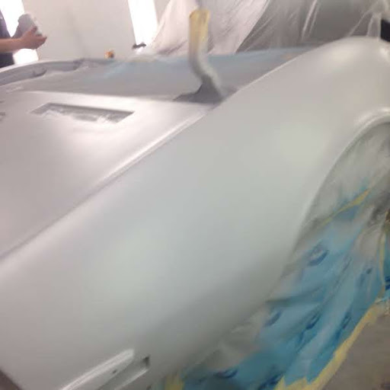
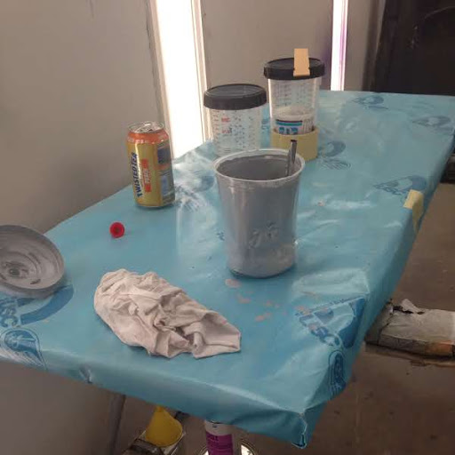

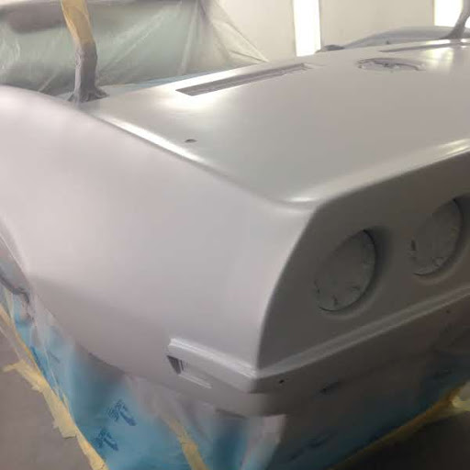
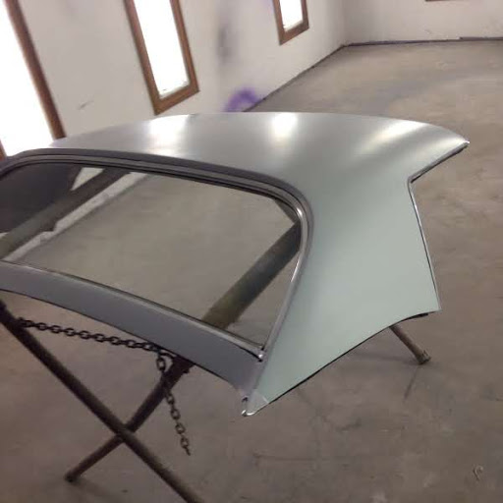

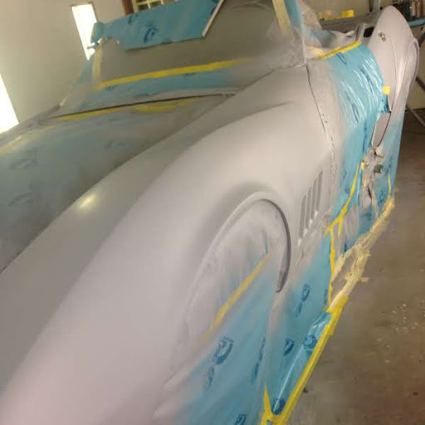
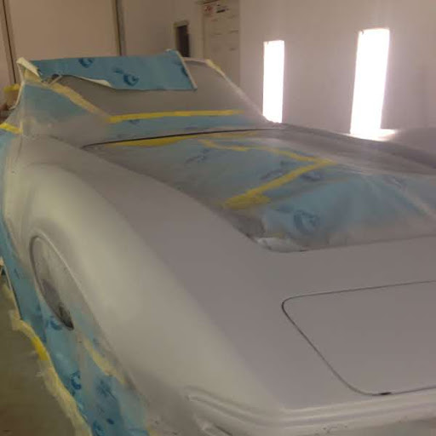

2001 Corvette C5: Return of the Z06 - A Classic - Reinvented

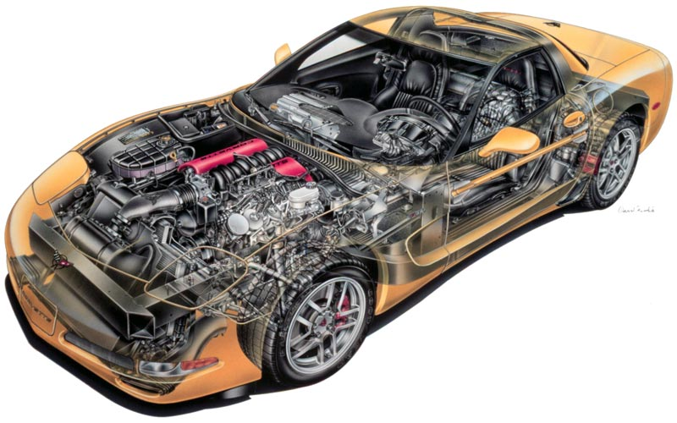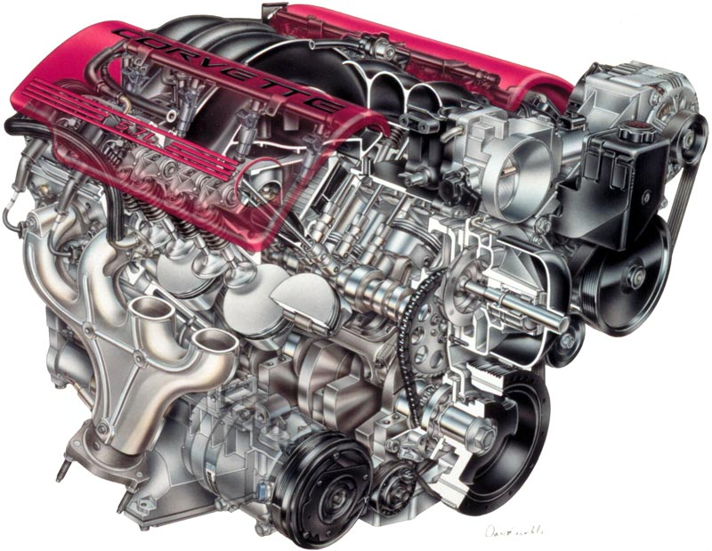

David Kimble drawing courtesy of GM

For 2001 the hardtop Corvette offered some exciting performance upgrades and GM dipped into the past for a suitable nameplate: the Z06. Z06 was the designation for a special option package for race destined Corvettes in 1963 and was the brainchild of engineer Zora Arkus-Duntov.

The new Z06 was equipped to be a dual purpose car: one that is at home on both the race track and public roads. Track days for amateur race car drivers had become popular and the Corvette lineup now featured a worthy participant.
The star of the new Z06 was the LS6 engine which was named in honor of the 454 cu in. 425 hp motor available in 1971. It is based on the LS1 that powers the convertible and coupe Corvettes; both engines have 5.7 liters (346 cu in) of displacement. The Z06 is rated at 385 hp @ 6,000 RPM and the LS1 is 350 hp @ 5,600 RPM. The increase is due to higher compression cylinder heads (LS6 > 10.5:1; LS1 > 10.1:1) with improved porting, larger fuel injectors, a more aggressive camshaft, stronger valve springs and better crankcase pressure management along with speedier oil return. Backing up the improvements (pun intended) was a less restrictive lighter weight titanium exhaust system. Red engine covers gave the LS6 some visual distinction.

Worth noting is the 385 hp rating of the LS6, which is 10 hp more than the LT5 found in the 1990 ZR-1. The simpler and less pricey two valve single camshaft design had conclusively proved itself over the complex and expensive four valve / four cam concept.

2001 Corvette Options, Prices

RPO | Description | Production | Price
1SB* | Preferred Equipment Group-Sport Coupe | 2,514 (7.06%) | $1,639.00
1SB** | Preferred Equipment Group-Convertible | 1,710 (4.80%) | $1,769.00
1SC*** | Preferred Equipment Group-Sport Coupe | 11,558 (32.44%) | $2,544.00
1SC**** | Preferred Equipment Group-Convertible | 11,881 (33.35%) | $2,494.00
79U | Millennium Yellow with tint coat | 3,887 (10.91%) | $600.00
86U | Magnetic Red Metallic Paint (coupe and convertible) | 3,322 (9.32%) | $600.00
AAB | Memory Package (Z06 hardtop) | 4,780 (13.42%) | $150.00
B34 | Floor Mats | 34,907 (97.98%) | $25.00
B84 | Body Side Moldings | 20,457 (57.42%) | $75.00
C2L | Dual Removable Roof Panels (coupe) | 5,099 (14.31%) | $1,100.00
CC3 | Removable Roof Panel, blue tint (coupe) | 4,769 (13.39%) | $650.00
DD0 | Electrochromic Mirrors (Z06 hardtop) | 4,576 (12.84%) | $120.00
F45 | Selective Real Time Damping (coupe and convertible) | 5,620 (15.77%) | $1,695.00
G92 | Performance 3.15 Axle (automatic, coupe and convertible) | 12,882 (36.16%) | $300.00
MN6 | 6-Speed Manual Transmission (coupe and convertible) | 16,019 (44.96%) | $815.00
N73 | Magnesium Wheels (coupe and convertible) | 1,022 (2.87%) | $2,000.00
QF5 | Polished Aluminum Wheels (coupe and convertible) | 22,980 (64.50%) | $895.00
R8C | Corvette Museum Delivery | 457 (1.28%) | $490.00
U1S | Remote 12-Disc Changer (coupe and convertible) | 14,198 (39.85%) | $600.00
UL0 | Delco Stereo Cassette (replaces standard radio) | 6,844 (19.21%) | n/a
UN0 | Delco Stereo System with CD | 28,783 (80.79%) | $100.00
V49 | Front License Plate Frame | 18,935 (53.15%) | $15.00
Z51 | Performance Handling Package (coupe and convertible) | 7,817 (21.94%) | $350.00

Total Production: 35,627
Coupe: 15,681 (44.01%)
Convertible: 14,173 (39.78%)
Z06: 5,773 (16.20%)

Notes: Base Corvette Coupe with 346 cu. in. 345 hp engine and four speed automatic transmission: $40,475.00.
Base Corvette Convertible with 346 cu. in. 345 hp engine and four speed automatic transmission: $47,000.00.
Base Corvette Hardtop Z06 with 346 cu. in. 345 hp engine and six speed manual transmission: $47,500.00.

Colors
Code | Exterior | Quantity | Interior | Soft Top
11 | Light Pewter Metallic | 3,462 (9.72%) | Black / Light Gray / Red | Black / White
12 | Quicksilver Metallic | 4,822 (13.53%) | Black / Light Gray / Red | Black / White
28 | Navy Blue Metallic | 2,587 (7.26%) | Black / Light Gray / Light Oak | Black / Light Oak / White
40 | Speedway White | 2,465 (6.92%) | Black / Light Gray / Light Oak / Red | Black / Light Oak / White
41 | Black | 6,971 (19.57%) | Black / Light Gray / Light Oak / Red | Black / Light Oak / White
70 | Torch Red | 7,192 (20.19%) | Black / Light Gray / Light Oak / Red | Black / Light Oak / White
79 | Millennium Yellow | 3,887 (10.91%) | Black | Black / White
86 | Magnetic Red Metallic | 3,322 (9.32%) | Black / Light Gray / Light Oak | Black / Light Oak / White
91 | Dark Bowling Green Metall | 919 (2.58%) | Black / Light Gray / Light Oak | Black / Light Oak / White

2001 Packages
RPO | Description | Contains | Production | Price
1SB | Preferred Equipment Group - Coupe | Six way power passenger seat, dual zone A/C, auxillary lamps, memory package and luggage / parcel shade. | 2,514 (7.06%) | $1,639
1SC | Preferred Equipment Group - Coupe | 1SB equipment + electrochromic mirrors, heads-up instrument display, twilight sentinal and telescopic power steering column | 11,558 (32.44%) | $2,544
1SC | Preferred Equipment Group - Convertible | 1SB equipment + electrochromic mirrors, heads-up instrument display, twilight sentinal and telescopic power steering column | 11,881 (33.35%) | $2,494

KOMEDY CORNER

Some Random Funnies

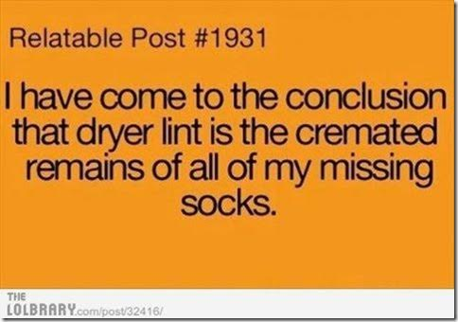

Biblical Theme Songs

Noah: "Raindrops Keep Falling on My Head"

Adam and Eve: "Strangers in Paradise"

Lazarus: "The Second Time Around"

Esther: "I Feel Pretty"

Job: "I've Got a Right to Sing the Blues"

Moses: "The Wanderer"

Jezebel: "The Lady is a Tramp"

Samson: "Hair"

Salome: "I Could Have Danced All Night"
Daniel: "The Lion Sleeps Tonight"

Esau: "Born To Be Wild"

Shadrach, Meshach, and Abednego: "Great Balls of Fire!"

The Three Kings: "When You Wish Upon a Star"

Jonah: "Got a Whale of a Tale"

Elijah: "Up, Up, and Away"

Methuselah: "Stayin' Alive"

Nebuchadnezzar: "Crazy"
