MASON DIXON Blue and Gray
March 2019

~Member ~ National Corvette Restorers Society (NCRS)

~ NCRS TOP FLIGHT CHAPTER OF THE YEAR ~ Former Winners for Fifteen Consecutive Years

~ NCRS & Mason Dixon Activities ~ Judging Events – Rallyes – Drags – Cruisin’Nights – Day Trips - Banquets – Weekend Outings -
Annual Atlantic City Bus Tour

~ Charities ~ Support numerous Charities throughout the Great State of Maryland

Contents

Chairman’s Report
Gus Tsamouras

Vice Chairman’s Report
Jim Buckley

Treasurer’s Report
Rd Ranier

Recording Secretary’s Report
Eileen Lesser

Membership Chairman’s Report
Glenn Gitschier

Judging Chairman’s Report
Rick Aleshire

Social Activities Chairman’s Report
Steve Lesser

Historian’s Report
Jerry Blumenthal

Website Coordinator’s Report
Jim Cella

Rebuilding Battery Box on 1998
James Buckley - NCRS #23431

Final Paint 1970 Corvette
James Buckley - NCRS #55336

Corvette History
Spotlight on 2002

Komedy Korner
Chairman’s Report Gus Tsamouras

Hello Fellow Mason Dixon Chapter Members!

I hope everyone had a great winter and enjoyed the holidays. I am very excited about our upcoming year. It will be quite hard to top last year but I am sure we can do it. We have a fantastic calendar year of events set up and hope everyone can participate in as much as they can.

Our first judging event is scheduled for April 7th at Ron Adams Chevrolet. It looks as though we have a full house with as many as 6 Chapter members participating! This is very exciting and I look forward to seeing all the great cars that will be participating. As usual Ron Adams is quite generous for letting us use his facility and I encourage anyone who is in the market for a car to give him a call.

Please take a look at our calendar of events and try to participate in as many events as possible as there is something for everyone. I would like some suggestions from our members for a potential second charity for this year.

Ok, everyone please gas up and dust off your cars! I hope to see everyone soon.

Sincerely,
Gus Tsamouras, Chapter Chairman
Mason Dixon Chapter, NCRS

Vice Chairman’s Report
Jim Buckley

Dear Fellow Chapter Members,

We are off to another new year of fun and games with our Corvettes. The events that the BOD, primarily Steve and Eileen, have lined up for us to participate in are outstanding. Just to mention one, The Morgan Town Auto Mall is something we did not do before. You could drive there on your own, or join the merriment of a chartered bus ride. Afterwards, lunch at the Shady Maple (largest all you can eat buffet in America). Should be fulfilling to say the least. Please come out and join us.

Also we have a Spring Dinner Meeting at Liberatore's and a Spring Judging meet at Ron Adams Chevrolet in the works. Consult your calendar. We will be looking for you.

So please come out in 2019 and join the "FUN".

Be there or be square........Vice Chairman, Jim

Treasurer's Report
Ed Ranier

The balance on the account, per the last bank statement for 1/16/19 was $15,223.54. The current, adjusted balance, as of 1/16/19, is $15,223.54, according to the checkbook. Thanks, Ed

Recording Secretary’s Report
Eileen Lesser
Minutes of the Board Meeting
Jerry Blumenthal Office
Timonium, MD
Wednesday, January 16, 2019

Attendance:
J. Buckley G. Gitschier E. Ranier E. Lesser
J. Blumentha S. Lesser J. Cella

Chairman’s Report:
Jim Buckley, Vice-Chairman, began the meeting in Gus’s absence by discussing:
- Judging event at Ron Adams Chevrolet on April 7;
- We will be having an election of officers in April for the 2019-2021 term;
- Member of the Year Award at the April dinner meeting.

Vice-Chairman’s Report:
Jim Buckley announced that our statistics are up-to-date, but we may not obtain another Chapter of the Year Award this year due to IRS paperwork. With the government shutdown, we are unable to get the paperwork needed to National NCRS.

Treasurer’s Report:
Ed gave an update on the Chapter Treasury which has $15,223.54 in it.

Membership Report:
Glenn gave an update on the number of members in the Chapter (98 members with 6 unpaid members).

Webmaster’s Report:
Jim Cella mentioned that “For Sale” items are limited to 30 days on the website. Apparel will also be on our website in the near future.

Judging Chairman’s Report:
In Rick’s absence, Jim mentioned that we need 6 technical articles for the year, with two for the next “Blue and Gray” Newsletter as well as cars to be judged. If you would like to have your Corvette judged, contact Rick Aleshire at mdninja1@hotmail.com.
Secretary’s Report:
Eileen Lesser read the “Good and Welfare.” Eileen will be sending out ballots in the U.S. mail for election of officers in the next few weeks. The final election will be announced at the April 2019 dinner meeting as well as the “Member of the Year” Award. If you know someone in Mason Dixon that you would like to nominate, please contact Jerry Blumenthal or Steve Lesser and give them the name of the nominee.

Social Activities Chairman’s Report:
We are working on the 2019 Calendar of Events. All events are tentative until we finalize the dates, times, locations, etc. Most of the events will be preceded by a flyer sent to our members by e-mail. A tentative calendar is attached to these minutes.

Good and Welfare:
- Congratulations to Mike and Lynn Streckfus on the birth of their newest granddaughter, Gemma Kathryn;
- The Board of Directors wishes Rick Aleshire a speedy recovery since his accident and surgery.
The meeting ended at 8:15 p.m. The next Board of Directors meeting will be on Wednesday, March 13, 2019 at Steve and Eileen Lesser’s home, 3304 Timberfield Lane, Baltimore, MD 21208.

Minutes of the Board Meeting
Eileen / Steven Lesser’s home
Pikesville, Maryland
Wednesday, March 13, 2019
Attendance:
J. Buckley G. Gitschier E. Ranier E. Lesser
S. Lesser J. Cella G. Tsamouras

Chairman’s Report:
Gus began the meeting by discussing:
- Judging event at Ron Adams Chevrolet on April 7; approximately 7-8 cars will be judged 6 of which are member cars;
- We will be having an election of officers in April for the 2019-2021 term; and the names will be announced at the dinner meeting;
- Member of the Year Award will be nominated and will be announced at the April dinner meeting;
- Sunday event for Corvettes car rally which came via e-mail; Rob Gicking, General Manager at Spring Meadow Station in Upperco, MD would like our car group to select a Sunday and have a car rally;
- Our Treasury had a problem in February 2019; all monies were removed; reports to the bank and to the police have been made, and we are trying to finalize this problem and return the money to our Treasury.

Vice-Chairman’s Report:
Jim Buckley announced that our statistics are up-to-date.

Treasurer’s Report:
Ed gave an update on the Chapter Treasury which has $38.00 in it. When registration monies are deposited the account should have around $800.00.

Membership Report:
Glenn gave an update on the number of members in the Chapter (97 members)

Webmaster’s Report:
Jim Cella mentioned that “For Sale” items are limited to 30 days on the website. Apparel will also be on our website in the near future and possibly a change in logo as well.

Judging Chairman’s Report:
In Rick’s absence, Gus mentioned that we need 6 technical articles for the next “Blue and Gray” Newsletter as well as cars to be judged. If you would like to have your Corvette judged, contact Rick Aleshire at mdninja1@hotmail.com.

Secretary’s Report:
Eileen Lesser read the “Good and Welfare.” Eileen sent out ballots in the U.S. mail for election of officers. The final officers’ names will be announced at the April 2019 dinner meeting as well as the “Member of the Year” Award. Glenn will take care of obtaining the plaque for the MOTY. If you know someone in Mason-Dixon that you would like to nominate, please contact Jerry Blumenthal or Steve Lesser and give them the name of the nominee.

Social Activities Chairman’s Report:
We are working on the 2019 Calendar of Events. All events are tentative until we finalize the dates, times, locations, etc. Most of the events will be preceded by a flyer sent to our members by e-mail. A tentative calendar is attached to these minutes. Gus will print and copy the 2019 calendar so that we can distribute them at the April dinner meeting.

Good and Welfare:
- Congratulations to Mike and Lynn Streckfus on the birth of their newest granddaughter, Gemma Kathryn;
- The Board of Directors wishes Rick Aleshire a speedy recovery since his accident and surgery;
- Welcome to new members Dennis Metzger, Steve & Karolyn Bertling, Bob & Phyllis Gavigan, K.C. & Sue Strawmyre, and Walter & Rosanna King.

The meeting ended at 8:25 p.m. The next annual Spring Dinner Meeting will be on Saturday, April 13, 2019 at Liberatore’s Ristorante in Lutherville, MD.

Respectfully submitted, Eileen Lesser
Recording Secretary

Web site: www.NCRS.org/masondixon
If you want to send a note through Yahoo, just e-mail the note to "mdncrs@yahoogroups.com". To start sending messages to members of this group, simply send e-mail to "MDNCRS@yahoogroups.com". If you do not wish to belong to MDNCRS, you may unsubscribe by sending an e-mail to "MDNCRS-unsubscribe@yahoogroups.com". If you are a member of other Yahoo e-mail lists, you may see and modify all of your group settings at http://groups.yahoo.com/mygroups

Membership Chairman's Report
Glenn Gitschier

As of 3-3-19, we have 97 members in our Chapter. Our latest members to join are Walter and Rosanna King, Bob and Phyllis Gavigan, Steve and Karolyn Bertling, and Dennis Metzger. Welcome to all!

It is very IMPORTANT that you notify the National and our Chapter if you change your email address. The National NCRS sends out reminder emails several months before the expiration date, so PLEASE don't ignore these reminders. I have also been sending emails and calling members if I see your National NCRS membership is going to expire within one month. Contact me (410-688-7329) if you want to know when your National NCRS membership expires. You must be a current member of National NCRS to remain a member of Mason Dixon. Also, if anyone is ever interested in knowing how many judging points you have, well I can now check that for you - just ask. Thanks, Glenn

Judging Chairman’s Report
Rick Aleshire

On Sunday, February 10 at Bruce Solomon's house in Owings Mills, MD we practice judged a beautiful 1964 co-owned by members Howard Fisher and Bruce Solomon. We also had a lengthy discussion on how to work with painters to achieve a "factory applied appearance" with current paint formulas. The following are pictures of the practice judging and are provided courtesy of Jim Buckley.
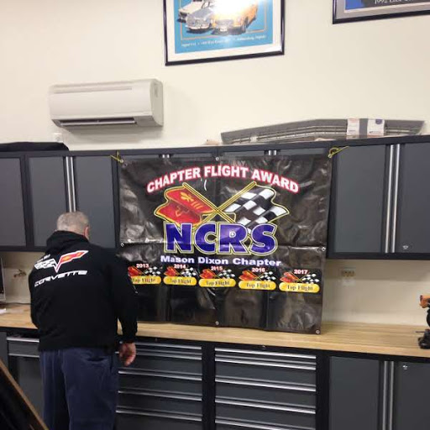
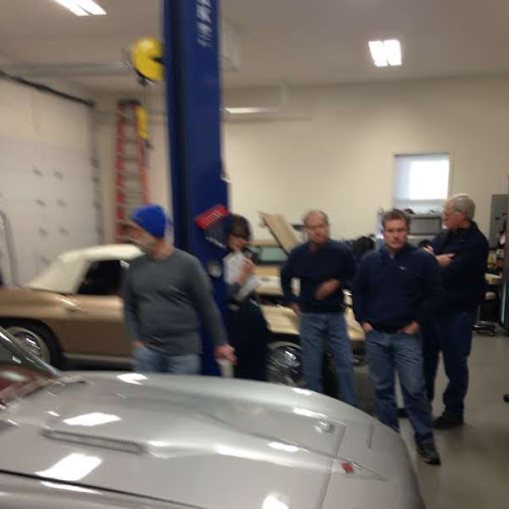
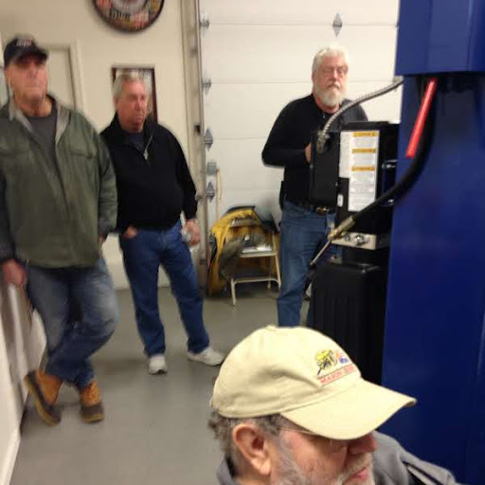

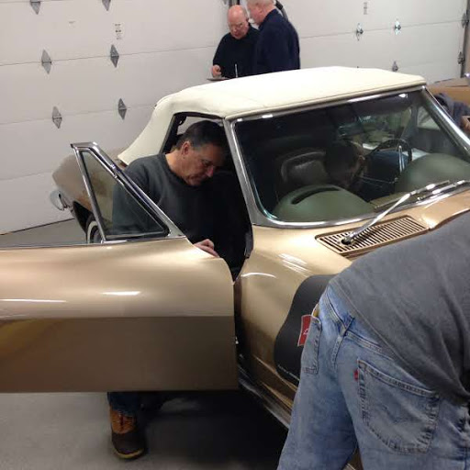
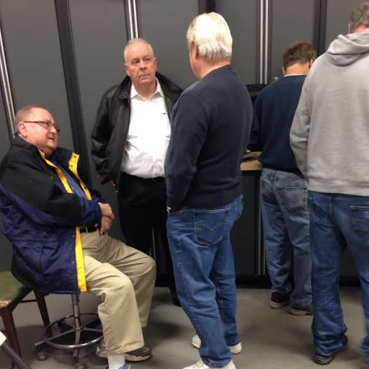
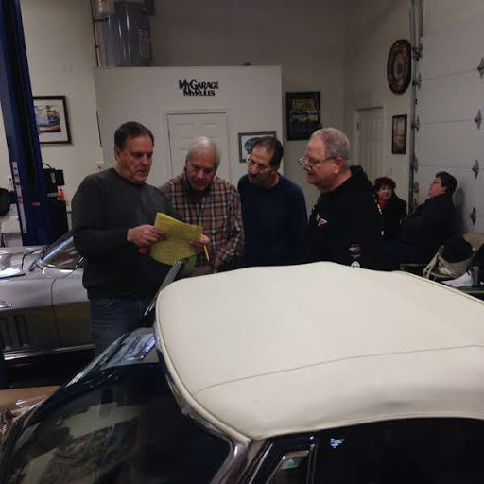

Mason Dixon @ Social Activities Report
Steve Lesser

2019 will be an exciting year for Mason Dixon. We have election of officers, Member of the Year Award, and lots of great activities planned. So get out your calendars now. I will wait until you get a pen and paper to mark down your favorite activities.
Once it stops raining and snowing, you can always attend every Saturday morning “Coffee and Cars” at Hunt Valley Mall from 8:00-10:00 a.m. Lots of our members attend this event, and you will see lots of exciting and unusual cars. No charge.

A new event on the calendar is the Road Trip to the Auto Mall in Pennsylvania on Saturday, March 16. If you are interested in going, call me at 410-484-9242. After the Auto Mall event, we will all go out to lunch and every member pays his own.

On April 7, we have our annual judging meet at Ron Adams Chevrolet in Havre de Grace, MD. Contact Rick Aleshire at 443-564-0720 for times and judging information or mdninja1@hotmail.com.
On Saturday, April 13 is our Annual Spring Dinner Meeting at Liberatore’s Ristorante from 6:00-10:00 p.m. You need to RSVP to Eileen at 410-484-9242 or eileen3304steve@verizon.net so we know how many are coming.

On Saturday, May 18 we will have “Ask The Experts.” If your Corvette is not running right, let the experts look it over. If it is running hot, if your timing is off, if the carburetor is not acting right, hopefully we can correct them for you.

A Corvette is made for fun. If you don’t drive it, or if you don’t participate in any of the events that Mason Dixon offers, how much fun can that be? Call me if you have any new ideas for road trips, lunches, dinners, charity events, etc. or email eileen3304steve@verizon.net.

On Saturday March 16, eleven members met at The Auto Mall, 6180 Morgantown Rd., Morgantown PA to view the collection of antinque and modern vehicles. To add to the theme, Julie and Steve Sokoloff drove their antique Rolls Royce and met the other members. After touring The Mall, everyone drove to the Shady Maple Smorgasboard for lunch. Looks like all had a GR8 time!
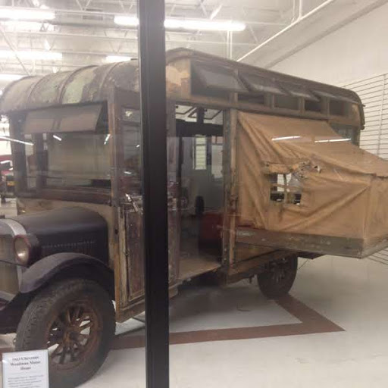
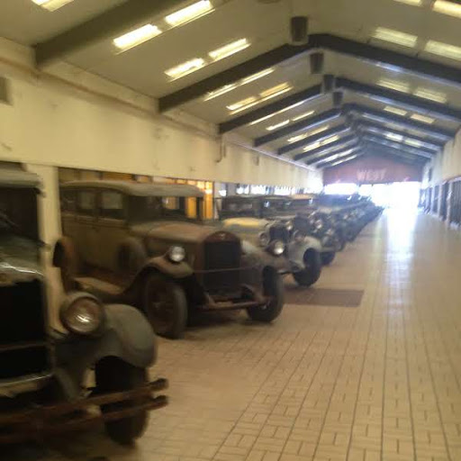
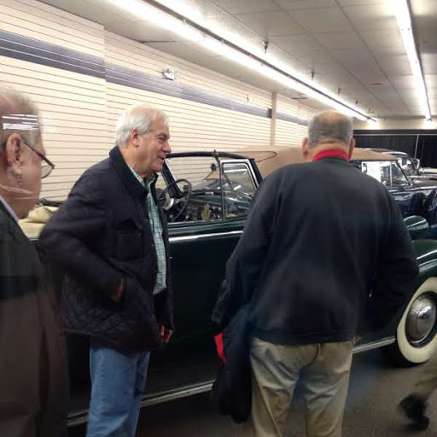

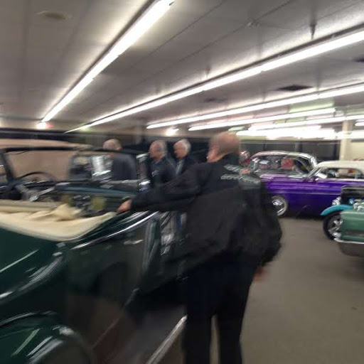
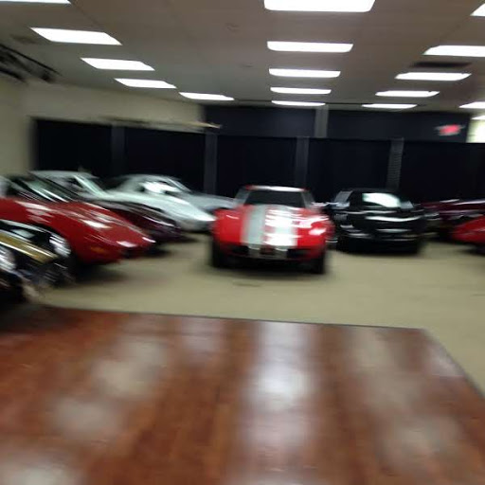
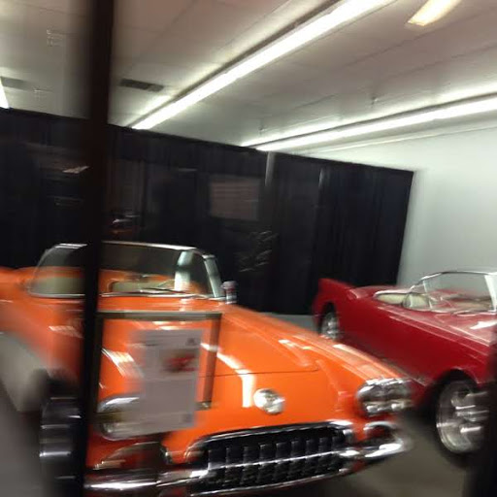

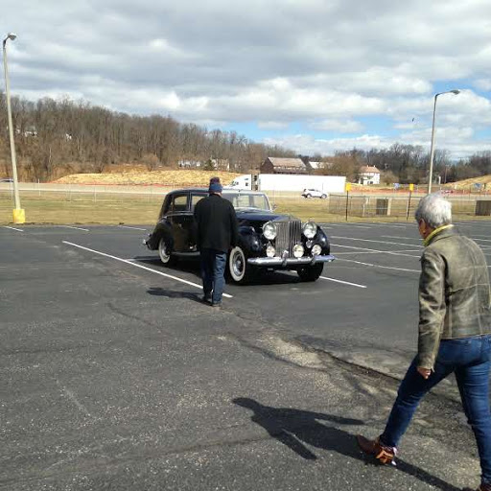
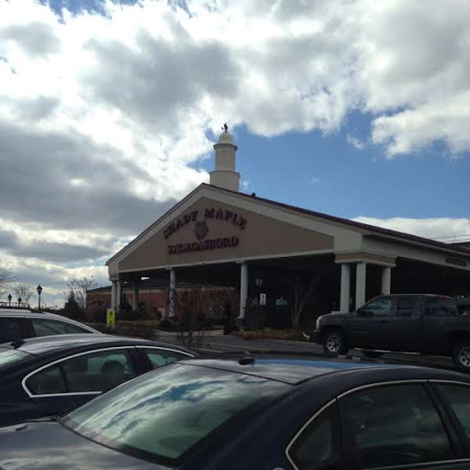
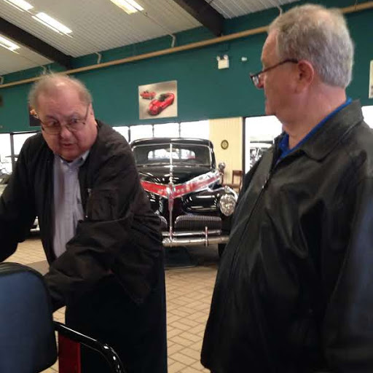

Historian’s Report
Jerry Blumenthal

Folks, we really do need everyone’s help here! If you have any pictures, stories, etc. to share with us all, please let Jerry or any of the BoD know.

Website Coordinator’s Report
Jim Cella

Folks, as the webmaster, I would like to get any comments, suggestions, etc. on the layout of the website. Again, this is your Chapter website and I will work to provide the information you need / want, but need to know. Thanks, Jim
Rebuilding Battery Box on 1998
James Buckley - #23431

Any wet cell battery is subject to leakage and side terminal batteries have an additional burden of holding back liquid acid. The lead side terminal is bonded to the plastic case to prevent leaks, but rough handling can loosen the bond. Over-tightening the battery cable retaining bolt can also break the bond. If the battery cable retaining bolt is too long, it can crack the lead terminal and allow acid to flow out of the bolt threads. Overheating during battery charging can damage the case and start a leak. This will be evident when you notice the battery case bulging out on all four sides. Battery leak can occur at the seam where the top and outer case bond together. There are products that may stop the flow, but for how long?
If you are using an O.E. or aftermarket replacement battery, install a Battery Mat first (part # 171002) to soak up any acid that might leak. The Battery Mat is a treated fiber mat that will retain and neutralize the acid. You still have to keep an eye on the terminals for the white corrosive powder because it is warning you that most likely acid is permeating the battery cable and headed towards the starter.

This is the best time to catch a problem. The cable terminals are corroded replacing the retaining bolt will eliminate further corrosion. The part number for correct cable retaining bolts is 173028 for 1969-2004 Corvettes. Be sure to check the length of original bolt before putting the replacement in the battery.

With the battery tray removed, you can see the harnesses below the battery along with the PCM (Powertrain Control Module) and TAC module. If this area has had battery acid spillage, thoroughly mix some baking soda and water (small box + quart water) and pour the mixture over the entire area. Then hose it out with tap water.
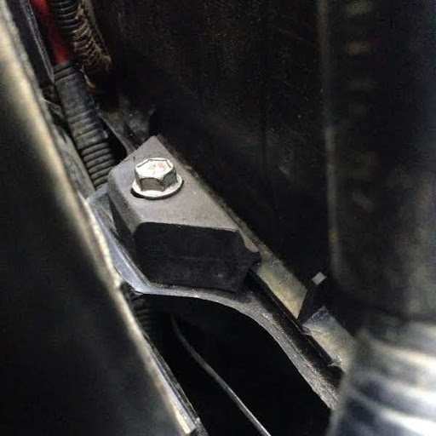
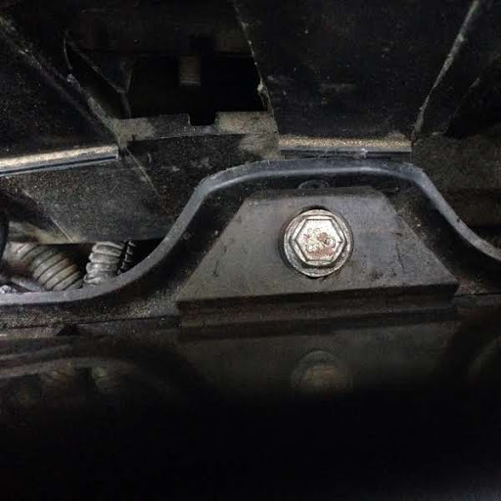
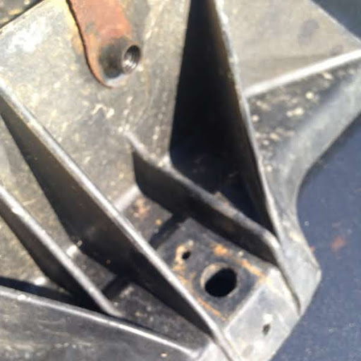

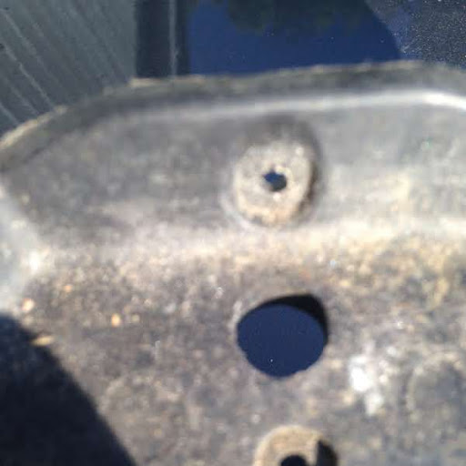
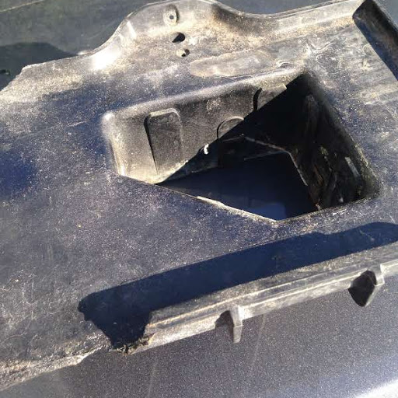

Final Paint 1970 Corvette
James Buckley - NCRS #55336

The following pictures show the final steps of getting the car back together and on the road. JOB WELL DONE!
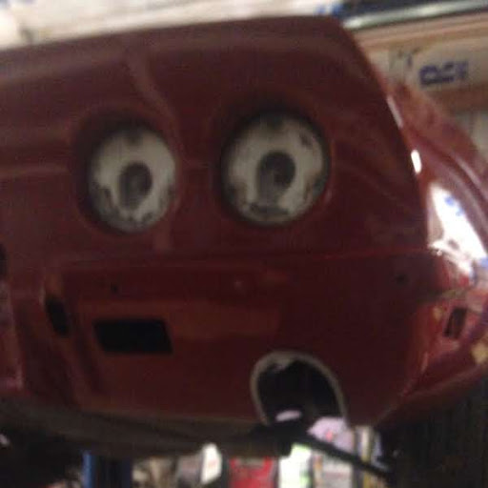
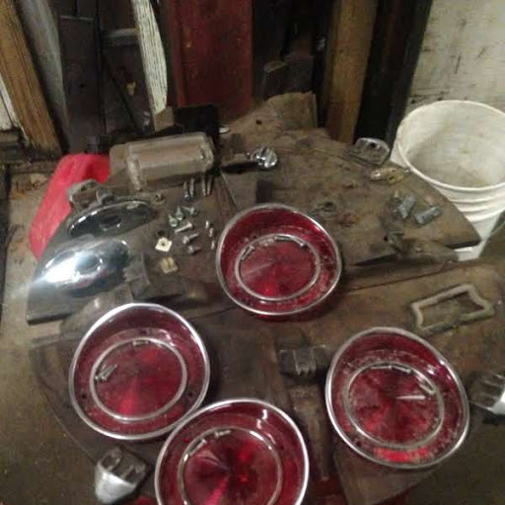

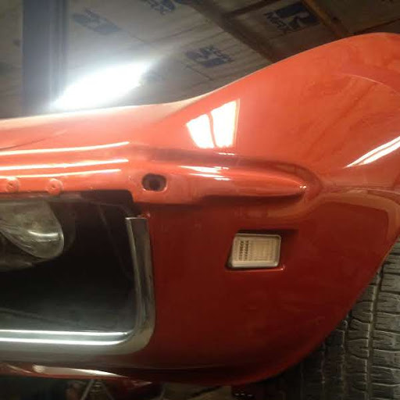
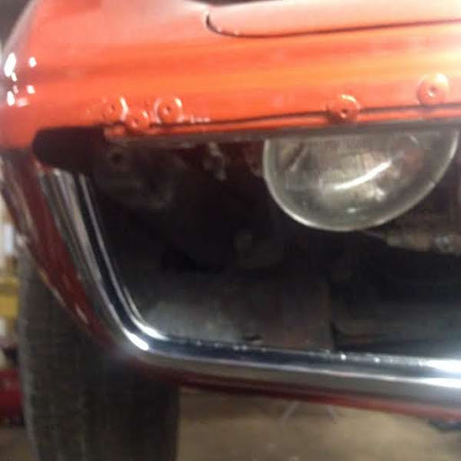

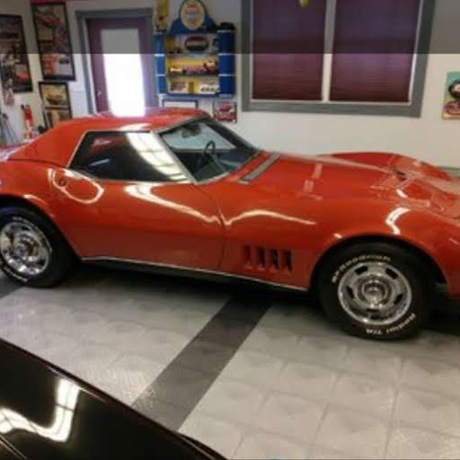
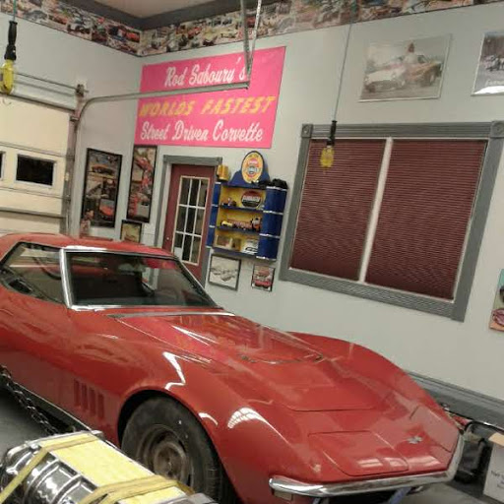

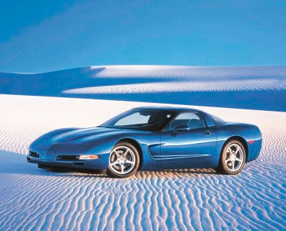
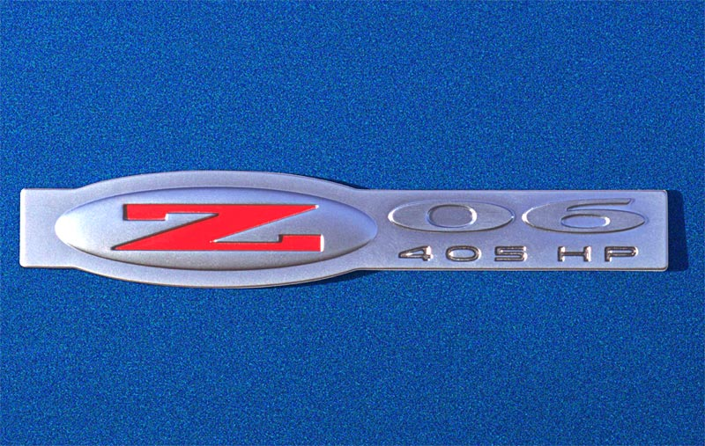
All Photos courtesy of GM

The 2002 Corvette was little changed from 2001, but included such improvements as a lighter cast aluminum automatic transmission case and cast aluminum stabilizer links in the optional Z51 Performance Handling Package. The hatchback was once again the most affordable 2002 Corvette at $41,450 plus a $645 destination charge. The standard roof panel was body color, but for $1,200 customers could also get transparent roof panels.

The front fender badge proudly announced a power upgrade for the 2002 Z06 LS6 motor: 405 hp. Lighter valves were used and the exhaust valves were liquid filled. Modifications to the intake resulted in better breathing. Two catalytic convertors were used where four used to do the job in 2001 and a revised higher lift camshaft was used. Different rear shock absorber settings and a beefier front anti-sway bar upgraded the handling.

Vehicle Specifications | Hatchback | Convertible | Coupe
Wheelbase, inches | 104.5 | 104.5 | 104.5
Length, inches | 179.7 | 179.7 | 179.7
Width, inches | 73.6 | 73.6 | 73.6
Track, inches | front: 62.1 rear: 62.2 | front: 62.1 rear: 62.2 | front: 62.1 rear: 62.2
Height, inches | 47.8 | 47.7 | 47.9
Curb weight, pounds | 3,246 | 3,248 | 3,11

Mechanical Specifications (2-door hatchback/convertible/coupe)
Suspension
front: Independent; upper and lower A-arms, transverse composite monoleaf spring, tube shock absorbers, antiroll bar
rear: Independent, upper and lower A-arms, toe links, transverse composite monoleaf springs, tube shock absorbers, antiroll bar
Wheels/Tires
front: P245/45ZR-17 (Z06, P265/40ZR-17)
rear: P275/40ZR-18 (Z06, P295/35ZR-18)
Brakes
front: anti-lock 12.6-inch disc
rear: anti-lock 11.6-inch disc
Transmission
4-speed automatic
6-speed manual
Standard axle ratio
2.73:1 (auto) 3.42:1 (manual)
Engine Specifications
Type | ohv V-8 | ohv V-8
Displacement, liters/cu inch | 5.7/350 | 5.7/350
Bore × stroke, inches | 3.90 × 3.62 | 3.90 × 3.62
Fuel management | Sequential Injection | Sequential Injection
Horsepower @ rpm | 350 @ 5,600 | 405 @ 6,000
Torque @ rpm, pound-foot | 375 @ 4,400 | 400 @ 4,800

Published Performance Numbers
Acceleration | 405 hp, 6-speed manual
0-60 mph, sec | 4.37
0-100 mph, sed | 9.85
1/4-mile, sec @ mph | 12.77 @ 113.65

2002 Corvette Options, Prices
RPO | Description | Production | Price
1SB* | Preferred Equipment Group-Sport Coupe | 1,359 (3.80%) | $1,700.00
1SB** | Preferred Equipment Group-Convertible | 1,379 (3.86%) | $1,800.00
1SC*** | Preferred Equipment Group-Sport Coupe | 11,136 (31.13%) | $2,700.00
1SC**** | Preferred Equipment Group-Convertible | 10,964 (30.65%) | $2,600.00
79U | Millennium Yellow with tint coat | 4,040 (11.30%) | $600.00
86U | Magnetic Red Metallic Paint (coupe and convertible) | 3,298 (9.22%) | $600.00
AAB | Memory Package (Z06 hardtop) | 7,794 (21.79%) | $150.00
B84 | Body Side Moldings | 21,422 (59.89%) | $75.00
C2L | Dual Removable Roof Panels (coupe) | 5,079 (14.20%) | $1,200.00
CC3 | Removable Roof Panel, blue tint (coupe) | 4,208 (11.77%) | $750.00
DD0 | Electrochromic Mirrors (Z06 hardtop) | 7,394 (20.67%) | $120.00
F45 | Selective Real Time Damping (coupe and convertible) | 4,773 (13.34%) | $1,695.00
G92 | Performance 3.15 Axle (automatic, coupe and convertible) | 9,646 (26.97%) | $300.00
MN6 | 6-Speed Manual Transmission (coupe and convertible) | 8,553 (23.91%) | $815.00
N73 | Magnesium Wheels (coupe and convertible) | 114 (0.32%) | $1,500.00
QF5 | Polished Aluminum Wheels (coupe and convertible) | 22,597 (63.18%) | $1,200.00
R8C | Corvette Museum Delivery | 371 (1.04%) | $490.00
U1S | Remote 12-Disc Changer (coupe and convertible) | 13,725 (38.37%) | $600.00
UL0 | Delco Stereo Cassette (coupe and convertible) | 4,210 (11.77%) | n/a
V49 | Front License Plate Frame | 19,948 (55.77%) | $15.00
Z51 | Performance Handling Package (coupe and convertible) | 6,106 (17.07%) | $350.00
Total Production: 35,767
Coupe: 14,760 (41.27%)
Convertible: 12,710 (35.54%)
Z06: 8,297 (23.20%)
Notes: Base Corvette Coupe with 346 cu. in. 345 hp engine and four speed automatic transmission: $40,475.00.
Base Corvette Convertible with 346 cu. in. 345 hp engine and four speed automatic transmission: $47,000.00.
Base Corvette Hardtop Z06 with 346 cu. in. 345 hp engine and six speed manual transmission: $47,500.00.

2002 Packages
RPO | Description | Contains | Production | Price
1SB | Preferred Equipment Group - Convertible | Six way power passenger seat, sport bucket seats, dual zone A/C, auxillary lamps, memory package and luggage / parcel shade. | 1,379 (3.86%) | $1,800
1SC | Preferred Equipment Group - Convertible | 1SB equipment + electrochromic mirrors, heads-up instrument display, twilight sentinal and telescopic power steering column | 10,964 (30.65%) | $2,600
1SC | Preferred Equipment Group - Coupe | 1SB equipment + electrochromic mirrors, heads-up instrument display, twilight sentinal and telescopic power steering column | 11,136 (31.13%) | $2,700

Colors
Code | Exterior | Quantity | Interior | Soft Top
11 | Light Pewter Metallic | 2,650 (7.41%) | Black / Light Gray / Red | Black / White
12 | Quicksilver Metallic | 4,618 (12.91%) | Black / Light Gray / Red | Black / White
21 | Electron Blue Metallic | 5,407 (15.12%) | Black / Light Gray / Light Oak | Black / Light Oak / White
40 | Speedway White | 1,763 (4.93%) | Black / Light Gray / Light Oak / Red | Black / Light Oak / White
41 | Black | 7,129 (19.93%) | Black / Light Gray / Light Oak / Red | Black / Light Oak / White
70 | Torch Red | 6,862 (19.19%) | Black / Light Gray / Light Oak / Red | Black / Light Oak / White
79 | Millennium Yellow | 4,040 (11.30%) | Black | Black / White
86 | Magnetic Red Metallic | 3,298 (9.22%) | Black / Light Gray / Light Oak | Black / Light Oak / White

KOMEDY CORNER

Hope these provide some smiles for YOUR day! You do NOT need to be a "senior" citizen to grin AT these !!!!
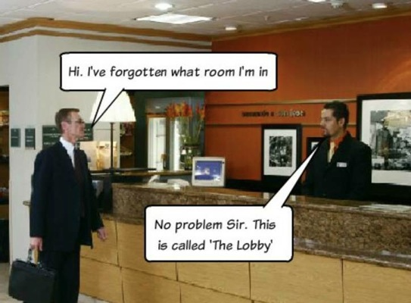

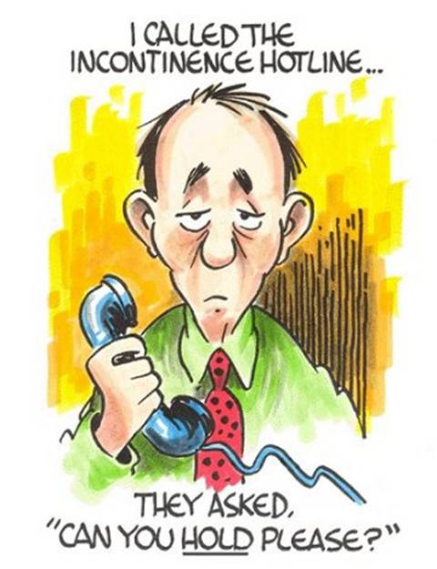

Mama's Scripture

My mom was the kind that'd send us to church but didn't go. She'd give us scripture and didn't even know it. She just made up books. ''Cause in the Book of Ricky, it says you should give your mama five percent of your gross income.'

A Wrinkle in Time

A little girl got on her grandpa's lap and said, "Did God make me?"

"Yes," the grandpa replied.

"Did God make you too?"

"Yes," the grandpa said.

"Well," the little girl said, looking at his wrinkles and thinning hair. "He sure is doing a better job nowadays!"

Basic Catholic Religion

I am a Catholic. Basically, the Catholic religion is 'If it feels good -- stop.'

Catholic Dad, Baptist Mom

My dad was Catholic, my mom was Baptist -- which was great 'cause at church we got bread and chicken.

Good Bar Mitzvah

Bar mitzvah was a good day in my life -- made more money that day than I think I'll ever make again.

Golf Study

A recent study found that the average golfer walks about 900 miles a year.

Another study found that golfers drink, on average, 22 gallons of alcohol a year.

This means that, on average, golfers get about 41 miles to the gallon!

Wedding Day

The bride was escorted down the aisle and when she reached the altar, the groom was standing there with his golf bag and clubs at his side.
She said: "What are your golf clubs doing here?"
He looked her right in the eye and said, "This isn't going to take all day, is it?"

A Tragedy, an Accident, and a Great Loss

George W. Bush is visiting a primary school and he visits one of the classes. They are in the middle of a discussion related to words and their meanings. The teacher asks the President if he would like to lead the discussion of the word "tragedy."

So the illustrious leader asks the class for an example of a tragedy. One little boy stands up and offers: "If my best friend who lives on a farm, is playing in the field and a runaway tractor comes along and knocks him dead, that would be a tragedy."
"No," says President Bush, "that would be an accident."

A little girl raises her hand: "If a school bus carrying 50 children drove over a cliff, killing everyone inside, that would be a tragedy."

"I'm afraid not," explains the exalted leader. "That's what we would call a great loss."

The room goes silent. No other children volunteer. President Bush searches the room. "Isn't there someone here who can give me an example of a tragedy?"

Finally at the back of the room, little Johnny raises his hand. In a quiet voice he says: "If Air Force One carrying you was struck by a missile and blown to smithereens, that would be a tragedy."

"Fantastic!" exclaims President Bush, "That's right. And can you tell me why that would be a tragedy?"

"Well," says the boy, "because it sure as hell wouldn't be a great loss and it probably wouldn't be an accident either."

Golf and the Pearly Gates

A golfer teed up his ball on the first tee, took a mighty swing and hit his ball into a clump of trees. He found his ball and saw an opening between two trees he thought he could hit through.
Taking out his 3-wood, he took a mighty swing. The ball hit a tree, bounced back, hit him in the forehead and killed him.
As he approached the gates of Heaven, St. Peter asked, "Are you a good golfer?"
The man replied: ”Got here in two, didn't I?

Phil Mickelson and Reporter

A gushy reporter told Phil Mickelson, "You are spectacular, your name is synonymous with the game of golf. You really know your way around the course. What's your secret?"
Mickelson replied, ”The holes are numbered."

Golf Poem

In My Hand I Hold A Ball,
White And Dimpled, And Rather Small.
Oh, How Bland It Does Appear,
This Harmless Looking Little Sphere.

By Its Size I Could Not Guess
The Awesome Strength It Does Possess.
But Since I Fell Beneath Its Spell,
I've Wandered Through The Fires Of Hell.

My Life Has Not Been Quite The Same
Since I Chose To Play This Stupid Game.
It Rules My Mind For Hours On End;
A Fortune It Has Made Me Spend.

It Has Made Me Curse And Made Me Cry,
And Hate Myself And Want To Die.
It Promises Me A Thing Called Par,
If I Hit It Straight And Far.

To Master Such A Tiny Ball,
Should Not Be Very Hard At All.
But My Desires The Ball Refuses,
And Does Exactly As It Chooses.

It Hooks And Slices, Dribbles And Dies,
And Disappears Before My Eyes.
Often It Will Have A Whim,
To Hit A Tree Or Take A Swim.

With Miles Of Grass On Which To Land,
It Finds A Tiny Patch Of Sand.
Then Has Me Offering Up My Soul,
If Only It Would Find The Hole.

It's Made Me Whimper Like A Pup,
And Swear That I Will Give It Up.
And Take To Drink To Ease My Sorrow,
But The Ball Knows...I'll Be BackTomorrow.

Kind of makes you proud. Almost makes you feel like a hybrid........

Funny Church Signs

"Come hear our Pastor, he's not very good but he's quick!"

"Changing churches? Does it matter which one you stay home from?"
"It's not your momma's church."
"Have trouble sleeping? We have sermons. Come hear one."
"Lent is coming - get your ash in church!"
"Keep using my name in vain. I'll make rush hour longer. - God"
"Flippin church of God."
"Drug addicts are welcome."
"God expects spiritual fruit, not religious nuts."
"To err is human. To arrrrr is pirate."

BLONDE MEN JOKES

A blonde man is in the bathroom and his wife shouts: "Did you find the shampoo?"
He answers, "Yes, but I'm not sure what to do... it's for dry hair, and I've just wet mine.
---------------------------------------------

A blonde man shouts frantically into the phone, "My wife is pregnant and her contractions are only two minutes apart!"
"Is this her first child?" asks the Doctor.
"No!" he shouts, "this is her husband!"
----------------------------------------------
An Italian tourist asks a blonde man: "Why do scuba divers always fall backwards off their boats?"
To which the blonde man replies: "If they fell forward, they'd still be in the boat."
-----------------------------------------------
Two blonde men find three grenades, and they decide to take them to a police station.
One asked: "What if one explodes before we get there?"
The other says: "We'll lie and say we only found two."
-----------------------------------------------
A friend told the blonde man: "Christmas is on a Friday this year."
The blonde man then said, "Let's hope it's not the 13th."

